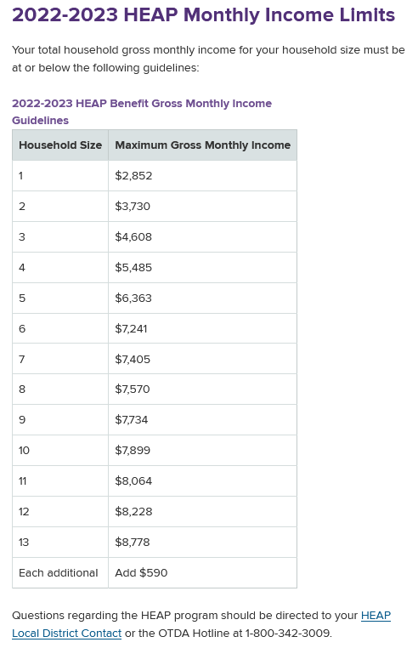

Source: https://otda.ny.gov/programs/heap/

