TIOGA OPPORTUNITIES, InC.
2023 COMMUNITY ASSESSMENT
A requirement of the Community Services Block Grant Organizational Standards

9 Sheldon Guile Blvd.
Owego, New York 13827
www.tiogaopp.org

Board of Director Approval 02.28.2023

Table of Contents
CHAPTER 1: INTRODUCTION
History of Community Action ……………………………………………………………..5
Three National Community Action Goals ……………………………………………6
The ROMA Framework ……………………………………………………………………….6
Agency Planning Process …………………………………………………………………….7
Breaking the Cycle of Poverty …………………………………………………………….8
State of the Grantee …………………………………………………………………………..9
CHAPTER 2: METHODOLOGY……………………………………………………….10
CHAPTER 3: COVID-19 UPDATE …………………………………………………..11
CHAPTER 4: STATISTICAL PROFILE OF TIOGA COUNTY
Geographic Location …………………………………………………………………………..13
Land Use …………………………………………………………………………………………….14
Composition & Density ……………………………………………………………………….16
Age ……………………………………………………………………………………………………..17
Race/Ethnicity and Languages …………………………………………………………….19
Disability Status ………………………………………………………………………………….19
Veterans …………………………………………………………………………………………….20
Households and Families …………………………………………………………………….21
CHAPTER 5: HOUSING
Physical and Environmental Conditions ………………………………………………24
Housing Stock …………………………………………………………………………………….26
Types of Fuels Used for Heating …………………………………………………………27
Income and Affordability ……………………………………………………………………28
Rental Assistance ……………………………………………………………………………….29

CHAPTER 6: EMPLOYMENT and ECONOMY
Employers in the County ………………………………………………………………..30
Industries and Occupations ……………………………………………………………30
Workforce Decline ………………………………………………………………………….32
Effects of the Pandemic on Businesses ……………………………………………33
“The Great Resignation” ………………………………………………………………….34
Wages and Income …………………………………………………………………………..36
Poverty and ALICE Rates and Data ……………………………………………………37
HEAP, SNAP, and Medicaid Participation ………………………………………….39
CHAPTER 7: EDUCATION
Educational Attainment ……………………………………………………………………40
Student Enrollments ………………………………………………………………………..42
School Quality and Student Performance …………………………………………42
Absenteeism …………………………………………………………………………………….44
Suspension and Expulsion …………………………………………………………………44
Free and Reduced Lunch …………………………………………………………………..45
Graduation Trends …………………………………………………………………………….46
Dropout Rates …………………………………………………………………………………..48
CHAPTER 8: TRANSPORTATION
Commuting to Work …………………………………………………………………………50
Vehicle Ownership …………………………………………………………………………..51
Transportation-Vulnerable Populations ……………………………………………51
Modes of Transportation ………………………………………………………………….52
Transportation Programs and Services ………………………………………………54
CHAPTER 9: HEALTH
Clinical Care ……………………………………………………………………………………….56
Preventive Care …………………………………………………………………………………58
Health Care Coverage ………………………………………………………………………….60
Behavioral Health ……………………………………………………………………………….60
Food Environment and Nutrition ………………………………………………………..61
Births and Prenatal Care ……………………………………………………………………..63
Mortality and Morbidity ……………………………………………………………………..65
Drug-related Overdoses and Deaths ……………………………………………………66
COVID-19 …………………………………………………………………………………………….69
CHAPTER 10: CHILD CARE
Available Child Care ……………………………………………………………………………71
What is Legally Exempt Child Care? ……………………………………………………72
Effects of COVID-19 on Child Care Closures ……………………………………….73
State Response – Stabilization Grants ………………………………………………..74
Child Care Assistance and Market Rates …………………………………………….75
Child Care Deserts ………………………………………………………………………………77
Current Initiatives ……………………………………………………………………………….77
CHAPTER 11: RECREATION and TOURISM ……………………………………………78
CHAPTER 12: PUBLIC SAFETY
Arrests ………………………………………………………………………………………………….80
Crime ……………………………………………………………………………………………………81
Domestic Abuse ……………………………………………………………………………………82
Recidivism …………………………………………………………………………………………….82
Protective and Preventative Services …………………………………………………….83
Foster Care & Adoption …………………………………………………………………………83
CHAPTER 13: EMERGENCY PREPAREDNESS
Emergency Services ……………………………………………………………………………..85
Natural, Technological and Man-Made Hazards …………………………………..86
Emergency Preparedness …………………………………………………………………….88
Disaster Assessment and Recovery ………………………………………………………88
CHAPTER 14: KEY FINDINGS …………………………………………………………………………….89
Acknowledgements…………………………………………………………………………………………..92

Chapter 1: Introduction

HISTORY OF COMMUNITY ACTION
Community Action Agencies were created in 1964 as a part of President Lyndon B. Johnson’s War on Poverty through the Economic Opportunity Act. The ultimate purpose of the “Act” was to give an opportunity for upward mobility to those who had been historically unable to participate in the mainstream of American life. The Economic Opportunity Act stated that the basic purpose of Community Action was “to stimulate a better focusing of all available local, State, private and Federal resources upon the goal of enabling low-income families and low-income individuals of all ages, in rural and urban areas, to attain the skills, knowledge, and motivations and secure the opportunities needed for them to become self-sufficient.” In addition to the direct services they provide, CAAs are leaders in promoting community economic development through community partnerships and inter-agency collaborations.
For over 55 years, Tioga Opportunities, Inc. (TOI) has been serving residents in and around Tioga County, New York, as a federally designated anti-poverty agency which provides community members with programs including, but not limited to, safe and affordable housing, financial education and stability, community awareness, and health and wellness programs. The governing Board of Directors is composed of one-third publicly elected officials, one-third representatives of people with low-income, and one-third representatives of the private sector, allowing for various viewpoints and expertise on both the issues and solutions affecting those in poverty. There are more than 1,000 CAAs throughout the United States; Tioga Opportunities, Inc. belongs to this strong, established network.

THE THREE NATIONAL COMMUNITY ACTION GOALS
The following National Community Action Goals inform the work of all CAAs across the nation. The goals are reflected in the National Community Action Network Theory of Change (below). A Theory of Change provides a conceptual road map for how an organization expects to achieve its intended impact.
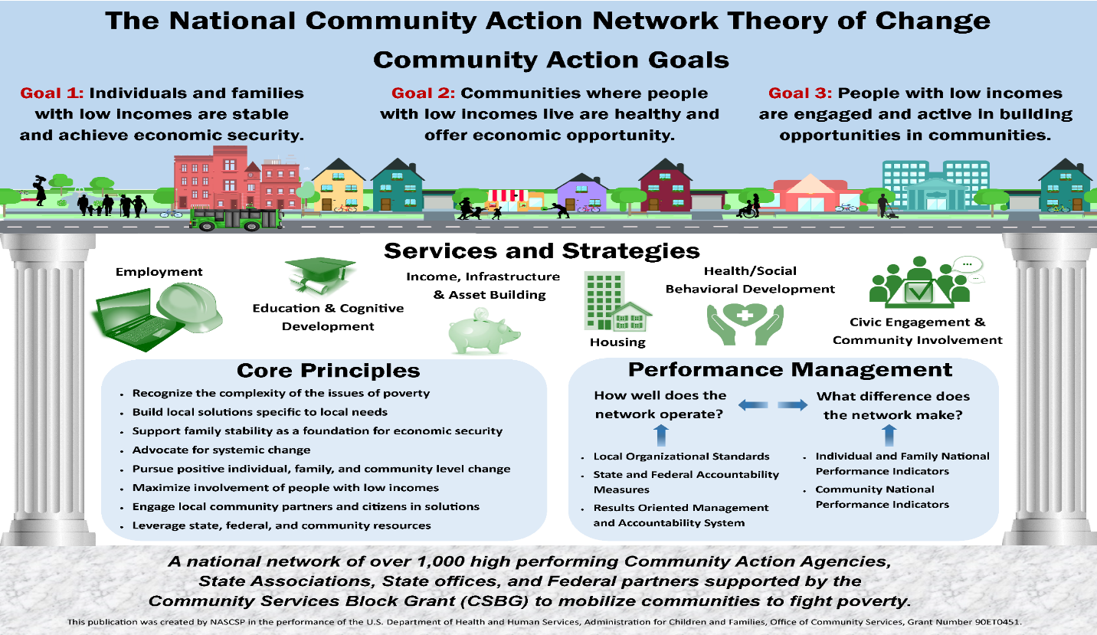

THE ROMA FRAMEWORK
In 1998, the Community Services Block Grant (CSBG) Act mandated the implementation of a comprehensive performance-based management system called Results Oriented Management and Accountability, commonly referred to as “ROMA,” across the entire Community Action network. The Monitoring and Assessment Task Force (MATF), a task force of federal, state, and local CSBG Network officials, created ROMA in 1994. Based upon principles contained in the Government Performance and Results Act of 1993, ROMA provides a framework of principles for continuous growth and improvement among local CAAs and a basis for state leadership and assistance. ROMA requires that CAAs develop and implement processes to identify, measure, and record improvements in the condition of people with low-incomes and the communities in which they live. Information about outcomes, or results, is then used to determine overall effectiveness of programs; inform annual and long-range planning; and promote new funding and community partnership activities. The ROMA cycle typically begins with an assessment, followed by planning, implementation, achievement of results, and most importantly, evaluation.
The implementation of the ROMA framework resulted in performance standards and a uniform system of national reporting indicators that have been adopted by all CAAs to better assess effectiveness and to increase the focus on impacts and benefits, or outcomes, of agency services (instead of simply the number of services delivered). The ROMA Cycle supports CAAs in better understanding what happens to the families and communities served by linking results to the identified needs and strategies employed by agencies to meet those needs.
AGENCY PLANNING PROCESS
Information-based strategic plans have been a foundation of the Community Action approach since the program’s earliest days. As a CAA, Tioga Opportunities, Inc. is legislatively mandated to identify community needs (as they relate to the elimination of poverty) and resources, and then create strategies that use new or existing resources to address those needs. A Community Needs Assessment is conducted to gather this information.
The Community Needs Assessment identifies and analyzes the community’s needs as well as existing resources or assets. The final document is used to develop the organization’s long-term strategy as well as shorter-term activities. As defined by the Community Action Partnership, a Community Needs Assessment is “a process conducted by all Community Action Agencies every three years to determine the underlying causes and conditions of poverty within the community they serve and identify the available resources to address the unmet needs of the community’s most vulnerable residents. The Community Needs Assessment is the first phase of the Results Oriented Management and Accountability (ROMA) Cycle, grounding and guiding the work to develop and implement programs and services that lift families and communities out of poverty.”
The Community Needs Assessment provides an opportunity for the CAA to:
- Understand emerging and existing needs and service gaps of economically insecure residents of the Tioga County service area
- Educate the community and its leaders about the needs and service gaps
- Determine the CAA’s role in meeting some of those needs and in lowering current and future barriers to community residents’ economic security
- Identify partnerships in the community that can help fulfill the CAA mission and address identified gaps
- Demonstrate to the community that the CAA has strategically chosen the most important issues to address, alone or with partners, and is using its resources most effectively

BREAKING THE CYCLE OF POVERTY
CAAs understand that increasing income alone will not break the cycle of poverty. An approach based on changing behavioral patterns that support asset development and address the underlying issues keeping households vulnerable must also be adopted. Assets include both tangible and intangible resources such as cash savings, a college education, stocks and bonds, or a home. Without assets, families may be able to subsist day-to-day, but will not be able to cope with a financial emergency, save for their children, or invest in a better future.

STATE OF THE GRANTEE
Tioga Opportunities, Inc. staff embrace a holistic, comprehensive, integrated service approach. Services are “bundled” to address a variety of underlying concerns within a household, leading to more significant outcomes for families. At Tioga Opportunities, Inc., approximately 65 staff members collaborate to provide the following services to residents in Tioga and neighboring counties:

SERVICES | PROGRAM
Safe & Affordable Housing | Home Repair
 | Rental Apartments for Older Adults & People with Disabilities
 | Rental Assistance
 | Energy Efficiencies & Weatherization
 | Radon Testing & Mitigation
 | Mobile & Manufactured Home Replacement
Financial Education & Stability | Budget & Credit Counseling
 | Financial Literacy Education
 | Home Appliance Loans
Community Education, Awareness, & Outreach | Information & Assistance
 | Caregiver Supports
 | Social & Recreational Activities for Older Adults
 | Newsletters & Social Media Outreach
 | Health Education
 | Educational Presentations
Health & Wellness | Exercise for Older Adults
 | In-Home Care Services
 | Respite Services
 | Medicare Insurance Counseling
 | Congregate Dining for Older Adults
 | Home Delivered Meals for Older Adults
 | Nutritional Counseling
 | Women, Infants, & Children (WIC)
 | Family Planning Program
 | Transportation Services
 | Disability Case Management

Chapter 2: Methodology
This Community Needs Assessment provides an update of the information that Tioga Opportunities, Inc. gathered since the last agency assessment which was published in early 2020. Soon after the publication of the document, the COVID-19 Pandemic took a prominent role in Tioga County and the entire world. Needs identified in the previous assessment were suddenly replaced with sudden, emerging needs, such as food, medicine, access to medical care, to name a few. Local community-based organizations, especially community action agencies, jumped into action and began to address the public health crisis facing the communities they serve. Tioga Opportunities, Inc. was no different.
A COVID update to the previous assessment was completed in early 2021. Surveys were distributed widely across the county in conjunction with other service providers to assess the challenges that families were facing because of the pandemic. These findings were added as an addendum to the previous assessment. Local Community Based Organizations, local government and eventually school districts began to meet virtually to provide context to the data and updates to the real-time situation in local neighborhoods and communities. Tioga Opportunities, Inc. did what it does best, jump into action, mobilize resources, and respond to emerging needs.
Senior management staff were taxed with the job of gathering current data and statistics in major areas affecting those we serve, such as housing, health, nutrition, etc. In preparing for this document, TOI has continued to use local data being compiled through a variety of resources (Tioga County Public Health and Social Services, Broome Tioga Workforce Development, New York State Community Action Association-NYSCAA, ALICE data), as well as, the newly publicized 2020 census data, the updated American Community Survey data and data from a variety of NYS funding sources.
Survey and focus group information that was gathered as part of TOI’s Strategic Planning process was also used in the development of this document. It should be noted that customer satisfaction surveys are collected all year and results and comments are reviewed quarterly and relevant information/feedback was used in the development of this assessment.
This document is unique within Tioga County and New York State in that it offers a focus on local conditions, emerging needs, analyzing the economic opportunities and barriers for all residents who are at risk of remaining or becoming economically insecure. It also identifies existing and potential resources to expand opportunities and prepares the TOI leadership team to plan a multi-year strategy.
The Statistical Profile of Tioga County section contains comprehensive statistical data on demographic and socioeconomic conditions of those residing in Tioga County. It provides a snapshot of those who do not currently qualify for agency services but who may in the near future, as referenced in the ALICE data set.
Data from primary and secondary sources is reflected throughout the document. The report presents findings and recommendations in the section of Key Findings at the end of the document.

CHAPTER 3: COVID-19 UPDATE
At the start of a new decade in 2020, the world was completely caught off-guard when the World Health Organization (WHO) declared a global pandemic on March 11, 2020. Coronavirus or COVID-19 became a household word and the world stood in disbelief as the reality of this pandemic began to set in.
On March 22, 2020, New York State was put on “Pause” with the issuance of Executive Order 202.6. Non-essential businesses throughout the state were basically shutdown, with employees being told to stay at home and stay indoors to the greatest extent possible. Essential businesses and services deemed necessary for the public’s health and safety, including many Community Action Agency services, were required to stay open. These CAA’s and businesses played a vital role in providing critical services to the economically disadvantaged and marginalized individuals throughout the state at an unprecedented time.
Community Action Agencies (CAA’s) responded to the global pandemic as it has in other national emergencies over the last 57 years. CAA’s were first responders, boots on the ground, and a frontline resource, assisting vulnerable households with the sudden challenges that the pandemic was presenting.
The COVID-19 pandemic changed everything – it changed how we thought about how and why and when we provide services. It challenged agencies to be innovative and creative and forced us to think out of the box regarding service provision. With community need rising in Tioga County, TOI knew that it had to remain steadfast in its ability to fulfil the promise of community action. This meant reaching out to existing and new partners, working with funders as they struggled to find ways to continue services during a global pandemic, and transition to virtual services wherever possible.
The challenge initially was that no additional dollars were flowing into CAA’s to provide the needed resources to adapt to the challenges of the pandemic. But on March 27, 2020, Congress passed the Coronavirus Aid, Relief, and Economic Securities Act (CARES). The Community Services Block Grant CARES Act provided $1 billion in supplemental funds to the states, authorized under the CSBG Act. These funds were the missing piece to TOI’s plan to respond to the growing needs here in Tioga County.
Much of the funding initially was geared toward addressing food insecurities, as schools and businesses closed. In partnership with local food pantries, food banks, and local school districts, drive through food distribution became weekly events. Dollars for rental and utility assistance was also utilized to support individuals that had been laid off indefinitely or lost their job permanently.
TOI needed to address the health & safety of its’ employees and residents residing in their housing complexes. Personal Protective Equipment (PPE) was ordered in bulk and staff were trained on how to sanitize surfaces safely. Eventually touchless sinks and toilets were installed in addition to doors at the Community Center. Agency policies and procedures needed to be revised and in some cases, rewritten. Management spent a good chunk of time revieing and making necessary edits to existing policies regarding emergency closings, sick time, remote work, and health & safety.
As vaccinations became approved and available, TOI partnered with the Tioga County Public Health Department and hosted several vaccination clinics at its warehouse. TOI staff also assisted with completing needed paperwork for each vaccination participant. Tioga County Public Health became the primary source of information regarding COVID related services and up-to-the-minute information coming from the Center for Disease Control and the federal government.
TOI recognized the very real stressors that its employees were dealing with regarding children being out of school, income being reduced due to layoffs and management soon realized that traditional employer practices would need to change. Flexible work hours/schedules, hybrid models, were implemented and pay incentives were provided to staff. Flexibility became the new operative phrase. Important work continued to get done while staff were dealing with their own personal struggles.
While there may have been a reduction in service hours and staff availability initially, TOI never shut its doors or stopped delivering critical access to services like WIC, Section 8 Housing Vouchers. The incredible staff at TOI never missed a beat. We rallied around each other and the community and have continued to shift and recenter as the pandemic has continued to evolve.
Needs of the community have shifted over the last 2 ½ years, but the one area that has remained as a major need is mental health interventions. The long-term effects of the pandemic on everyone, especially young children have been substantial. According to the National Library of Medicine*, survey studies regarding child and adolescent mental health amid COVID-19 indicated that anxiety, depression, loneliness, stress, and tension are the most observed symptoms.
As of 1/24/2023, the following data represents the number of COVID cases and deaths as follows:
COUNTY | Number of Confirmed Cases | Number of Confirmed Deaths
BROOME | 58,085 | 623
CHEMUNG | 26,398 | 285
CHENANGO | 11,708 | 148
TIOGA | 13,911 | 153
TOMPKINS | 26,231 | 106

As of 1/24/2023, the following data represents the percentage of each county population with the primary COVID-19 vaccination series.
COUNTY | Total Population | People with Primary Series | Percentage of People with Primary Series
BROOME | 191,659 | 127,218 | 66.4%
CHEMUNG | 84,254 | 46,845 | 55.6%
CHENANGO | 47,536 | 29,743 | 62.6%
TIOGA | 48,560 | 24,473 | 50.4%
TOMPKINS | 102,793 | 82,056 | 79.8%

CHAPTER 4: STATISTICAL PROFILE OF TIOGA COUNTY
Geographical Location
Tioga County is a predominantly rural county located in South Central New York (highlighted in red below). Tioga County is uniquely positioned in that it shares a border with both New York and Pennsylvania counties. (Map 4.1). In New York, Tioga is bordered by Chemung, Tompkins, Cortland, and Broome Counties and in Pennsylvania, Tioga borers Susquehanna and Bradford Counties.
MAP 4.1
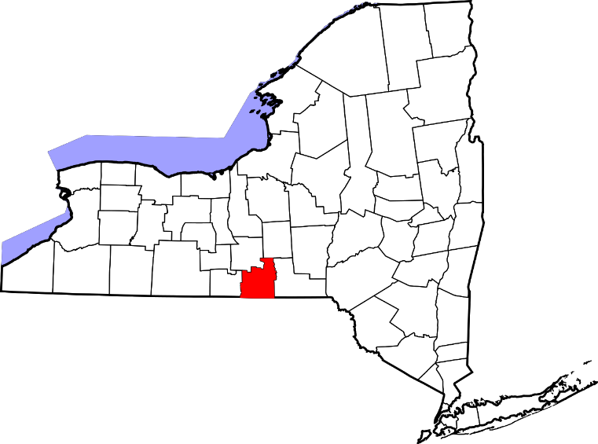
MAP 4.2
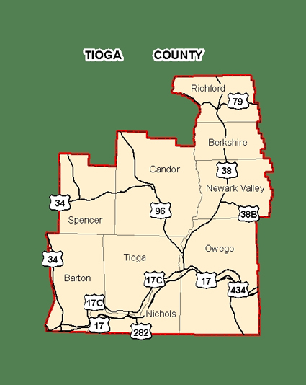

Tioga County contains the following municipalities: Town of Richford, Town of Berkshire, Town of Newark Valley, Town of Spencer, Town of Candor, Town of Barton, Town of Tioga, Town of Owego, Town of Nichols, Village of Waverly, Village of Candor, Village of Newark Valley, Village of Owego, Village of Spencer, and Village of Nichols. (Map 4.2)

Land Use
Tioga Opportunities, Inc. serves all of Tioga County, which consists of 331,940 acres of land and 33 miles of the Susquehanna River. The many quant villages and rolling hills within the County provide a variety of land use options to residents, including agricultural production and public parks. Table 4.1 below displays the land use of Tioga County as of 2013.
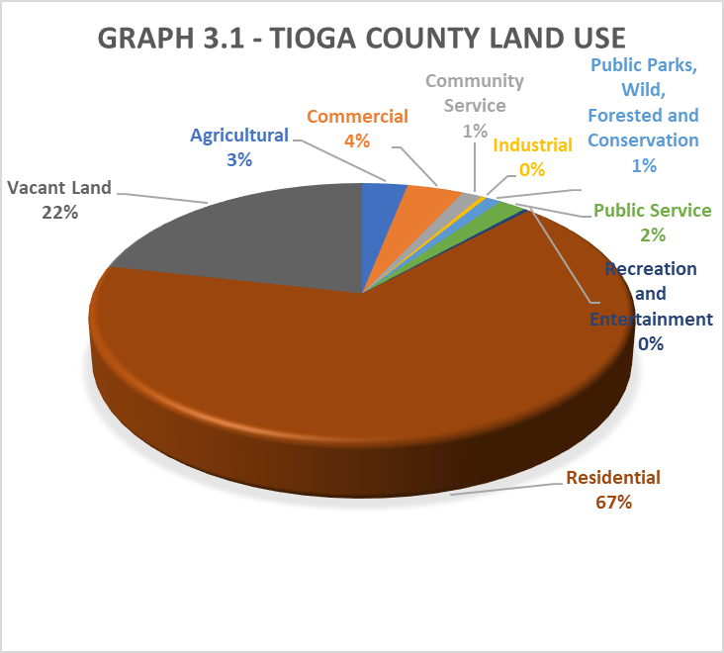

Only four municipalities (Towns of Owego and Nichols, and the Villages of Owego and Waverly), have official zoning districts, as indicated in the map below. Tioga County is considered the 42nd largest county in New York State by area and has a high percentage of agricultural land use; approximately 32.5% of its land is farms as seen in the map of the Agricultural Districts.
Map 4.3 – Zoning Districts
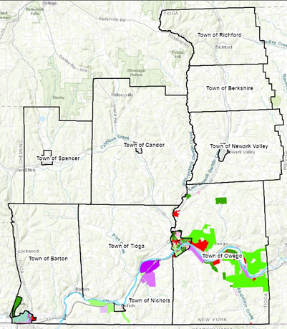
Map 4.4 – Agricultural Districts
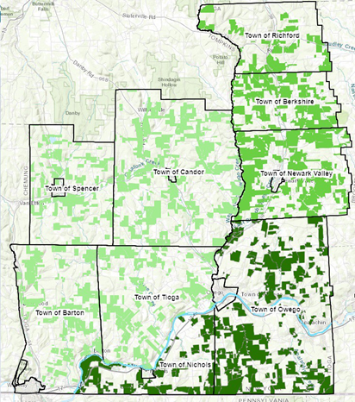
Although some large (500-999acres) and very large (1,000 acres or more) farming operations do exist within the county, most county operations are between 50 to 179 acres.

POPULATION DEMOGRAPHICS
Composition and Density
According to the 2020 Decennial Census, 48,455 people reside within Tioga County's nine towns and six villages. 49.6% of residents are male and 50.4% of residents are female. 65.66% of the Tioga County population is considered rural and the population per square mile is 93.4. MAP 3.6 below illustrates the population density of Tioga County by municipality. Within the service area, population centers can be found in the Villages of Owego and Waverly. Since the 2010 Census, Tioga County has lost 2,670 residents.
MAP 4.5 – Tioga County 2020 POPULATION PER SQUARE MILES AT COUNTY LEVEL
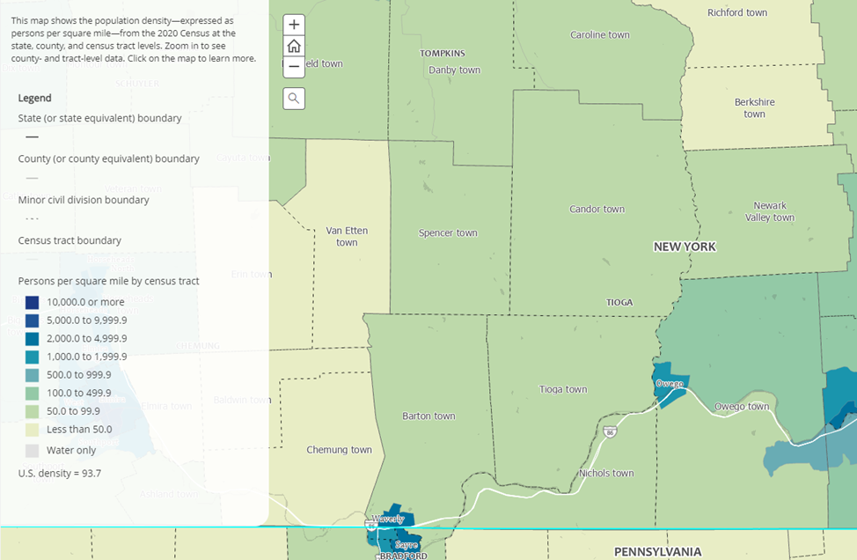

As TABLE 4.6 below reveals, Tioga County has seen a decline in its population within each municipality since 2010.
TABLE 4.6 - SUB COUNTY POPULATION CHANGE 2010 - 2020
Area | Total Population |  | Difference
 | 2010 Base | 2020 | Count | %
New York State | 19,378,087 | 19,336,776 | -41,311 | 2.2%
Tioga County | 51,123 | 48,455 | -2,670 | -3.3%
Towns
Barton | 8,858 | 8,335 | -523 | -2.9%
Berkshire | 1,412 | 1,351 | -61 | -3.1%
Candor | 5,307 | 4,933 | -374 | -3.6%
Newark Valley | 3,944 | 3,675 | -269 | -3.7%
Nichols | 2,519 | 2,401 | -118 | -1.6%
Owego | 19,891 | 18,517 | -1,374 | -3.6%
Richford | 1,172 | 1,108 | -64 | -3.3%
Spencer | 3,151 | 2,889 | -262 | -4.1%
Tioga | 4,869 | 4,695 | -174 | -2.3%
Source: U.S. Census Bureau Population Estimates 2010 -2020

AGE
The median age in Tioga County is 44.0 years old, which is higher than the New York State average of 38.7 years and the national average of 36.6 years. An estimated 17.4% of the population was under 15 years old, 33.8% was 15 to 44 years, 29.8% was 45 to 64 years, and 19.2% was 65 years and older.

TABLE 4.7 – AGE COHORTS BY AREA
AREA | Under 15 | 15 to 44 | 45 to  64 | 65 and  older
Tioga County | 17.4% | 33.8% | 29.8% | 19.2%
NYS | 17.4% | 40.2% | 26.6% | 15.5%
National | 18.8% | 39.9% | 26.0% | 15.2%
Source: 2020 ACS 5-Year Estimates

When comparing these age cohorts to New York State and national percentages, Tioga County appears to have fewer 15-44-year-olds and more people who are 45 to 64 years and 65 years and older. Between 2010 and 2040, the population loss is projected at more than 10,000 among residents age 15-64; while the 65+ population is expected to grow by 22.1% or 1,800 persons. The 85+ population is projected to grow by 31.3% or 305 persons. This rapid aging population is expected to level off and decline, beginning in 2030.

CHART 4.8 offers a future snapshot of the total population trend of Tioga County. That is, between 2010 and 2040, Tioga County can expect to lose 11,004 residents.
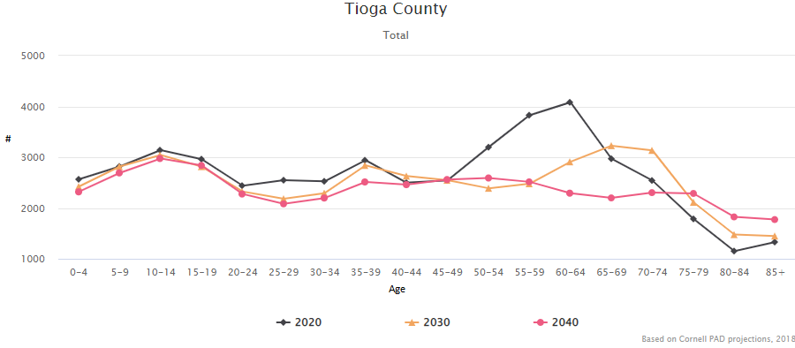
CHART 4.8 – TIOGA COUNTY POPULATION ESTIMATES BY AGE 2015-2040

Source: County Projections Explorer by Cornell Program on Applied Demographic

Overall, the population aging rates in Tioga County have increased dramatically within the last few years, like much of New York’s Southern Tier. According to the 2017 Tioga County Housing Study, this is fueled by decreases estimated within the younger working family cohort and net outmigration. The 2010-2015 American Community Survey estimates and the Cornell University Program on Applied Demographics trended data reveals increasing numbers and proportions of residents ages 65+ and 85+, as well as an increasing ratio of these persons to the working age population.

Race/Ethnicity and Languages
According to the 2020 Census, the majority of Tioga County residents were Caucasian or White (92.0%); 0.9% were Black or African American; 0.2% were American Indian and Alaska Native; 0.8% were Asian; 0.03% were Native Hawaiian and Other Pacific Islander; and 0.8% were of some other race. Among people at least five years old living in Tioga County, 2.7% spoke a language other than English at home. Spanish was spoken by 1.0% of people five years and older; other Indo-European languages were spoken by 1.0%; Asia and Pacific Island languages were spoken by 0.5%; and other languages were spoken by 0.1%. Of those languages spoken listed above, the follow percentages of speakers reported that they did not speak English very well: Spanish speakers 23.7%; Indo-European speakers 11.9%; Asian and Pacific Island speakers 49.1%; and other language speakers 21.2%.
TABLE 4.9 – COMPARISON OF LANGUAGES SPOKEN AT HOME AND ENGLISH FLUENCY
Age | Spanish | Indo-European | Asian & Pacific Island | Other | Speak English Very Well | Don't Speak English Very Well
5-17 years | 97 | 67 | 6 | 0 | 141 | 29
18-64 years | 306 | 322 | 205 | 35 | 661 | 207
65+ years | 73 | 80 | 15 | 17 | 130 | 55
TOTAL | 476 | 469 | 226 | 52 | 932 | 291
Source: 2020 Decennial Census

Disability Status
In Tioga County, 14.6% of the population reported having a disability according to the 2020 American Community Survey. This is higher than the New York State rate of 11.5% and the national rate of 12.6% As shown in TABLE 4.10, of the noninstitutionalized population, persons 65+ had the highest rate of reported disabilities, followed by persons aged 18 to 64 years.
TABLE 4.10 – NONINSTITUIONALIZED POPULATION WITH A DISABILITY BY AGE
 | People Under 18 | 18 to 64 years | 65+ years
TIOGA | 8.4% | 22.6% | 68.5%
NYS | 5.8% | 16.2% | 69.6%
NATIONAL | 6.1% | 19.0% | 74.2%
Source: 2020 American Community Survey, 5-year estimates

Table 4.11 below shows the percentage breakdown of type of disability with the highest percentage of 8.1% in ambulatory difficulty.
TABLE 4.11 - DISABILITY BY TYPE IN TIOGA COUNTY
Hearing Difficulty | 5.1%
Vision Difficulty | 2.9%
Cognitive Difficulty | 4.9%
Ambulatory Difficulty | 8.1%
Self-care Difficulty | 2.2%
Independent Living Difficulty | 6.0%
2020 American Community Survey 5-Year Estimates

Veterans
Tioga County has a civilian population 18 years and over of 38,538, 10.1% of whom are veterans. Tioga County veterans served in the two Gulf Wars (11.3% and 15.5%), Vietnam (37.9%), and Korea (10.4%), and WWII (5.8%). The largest proportion served in Vietnam and the smallest, due to the advancing age of this cohort, in World War II. The veterans who served in Korea represent the smallest percentage of the total population who have served; no data was available for service in Afghanistan, the Middle East, or elsewhere.
As shown in Table 4.12, 76.2% of Tioga County veterans participate in the labor force. Data shows that 5.7% of veterans in Tioga County have income in the last 12 months below the poverty line and 27.8% have a disability. Educational attainment appears to be higher than the general population according to the 2018 American Community Survey.
TABLE 4.12 – VETERAN CHARACTERISTICS, TIOGA COUNTY
Characteristic | % | Educational Attainment | %
Labor force participation | 76.2% | Less than high school graduate | 5.8%
Income above poverty rate | 94.3% | High school graduate (or equivalency) | 33.8%
Income below poverty rate | 5.7% | Some college or associate’s | 36.9%
With a disability | 27.8% | Bachelor’s or higher | 23.6%
Source: 2018 American Community Survey

The number of female veterans as compared to males continues to lag; the number of male veterans in Tioga County from 2015 to 2018 has been 13 to 14 times more than the number of female veterans as shown in TABLE 4.13 below.
TABLE 4.13 - TOTAL NUMBER OF TIOGA COUNTY VETERANS BY GENDER
Sex | 2015 | 2016 | 2017 | 2018
Male | 4067 | 3980 | 3892 | 3801
Female | 298 | 294 | 290 | 287
TOTAL | 4365 | 4274 | 4182 | 4088
Source: National Center for Veterans Analysis and Statistics

When examining the age of veterans in Tioga County (TABLE 4.14 below), we see that the high proportions of veterans are aged 65 to 74 years old (30.5%) and 75+ years (26.7%), suggesting that the veteran population in Tioga County is aging.
TABLE 4.14 - PERCENTAGE OF TIOGA COUNTY VETERANS BY AGE
Age | 2018
18 to 34 | 5.8%
35 to 54 | 17.5%
55 to 64 | 19.5%
65 to 74 | 30.5%
75+ years | 26.7%
Source: 2018 American Community Survey

Households and Families
According to the 2020 American Community Survey, there were 20,643 households in Tioga County with an average size of 2.32 people. Families comprised more than half of the households, at 67.1%, which includes both married-couple families (79.7%) and other families (20.3%). Data show 45.9% of all households in Tioga County include one or more person aged 60 or older while 41% of nonfamily householders living alone are 65 years and over.
Table 4.15 HOUSEHOLDS BY TYPE
Households by Type | Tioga County | NYS | National
 | Total % | Total % | Total %
Under 18 | 26.70% | 29.00% | 30.70%
Over 60 | 45.90% | 42.00% | 40.20%
Living Alone | 27.20% | 29.80% | 28.00%
65 and Older | 13.80% | 12.40% | 11.30%
Source: 2020 ACS 5-Year Estimates

Table 4.16 HOUSEHOLDS WITH CHILDREN
Age of Children | Tioga County | NYS | National
 | Total % | Total % | Total %
Under 6 years only | 23.20% | 22.30% | 21.50%
Under 6 years & 6 to 17 years | 19.60% | 18.90% | 20.00%
6 to 17 years only | 57.20% | 58.80% | 58.50%
Source: 2020 ACS 5-Year Estimates

The demographics of families are changing, including the feeling from young adults that “cohabitating relationships provide healthier options more conducive to personal development”. As shown by TABLE 4.12 on the following page, the percentage of “never married” residents in Tioga County is less than both the New York State and national average for both males and females whereas the percentage of “now married” residents in Tioga County is higher. The percentage of both male and female New York State residents whose marital status is "separated" is higher than the rate of the national and Tioga County. Tioga County also has a higher rate of widows than both the New York State and the nation rates, and Tioga County females have a significantly higher rate than their male counterparts. Divorce rates in Tioga County are also higher than New York State rates, but lower than national rates.
TABLE 4.17 - COMPARISON OF MARITAL STATUS BY AREA AMONG MALES AND FEMALES
Marital Status | Tioga |  | NYS |  | National
 | Males | Females | Males | Females | Males | Females
Never Married | 28.20% | 21.50% | 40.50% | 35.40% | 36.60% | 30.50%
Now Married | 58.80% | 54.90% | 47.80% | 42.80% | 49.70% | 46.60%
Separated | 1.80% | 2.20% | 1.80% | 2.70% | 1.60% | 2.10%
Widowed | 3.50% | 10.90% | 2.60% | 8.90% | 2.60% | 8.70%
Divorced | 7.80% | 10.50% | 7.30% | 10.20% | 9.40% | 12.10%
Source: 2020 ACS 5-Year Estimates
Many studies have shown the link between financial instability and relationship dissolution and divorce; researchers argue “a wide range of economic factors affect relationship quality and well-being… measures beyond earnings, such as family support and hardship, play an important role in predicting relationship quality… [research] shows that economic well-being can improve positive measures of relationship quality and that economic hardship can play a role in instigating couple conflict,”. Others state “experiencing periods of poverty, which…may prove disruptive to burgeoning romantic relationships” by increasing conflict and reducing intimacy. These may lead to Adverse Childhood Experiences (ACES). 47.8% of divorces in 2010 were among couples with one to two children under the age of 18 years old, and 27.5% of divorces were filed after 5 to 9 years of marriage. Research shows that children in stable, two-person households consistently demonstrate “better physical, emotional, and academic well-being” and with the exception of parents with unresolvable marital violence, children fare better when parents work at maintaining relationships. It is important to note that as of the 2019 American Community Survey, New York was fourth among the top ten states with the largest number of same-sex couple households, with an estimated 36,711 households.

HOUSING
Many studies have shown housing as a social determinant of health. Namely, healthy, safe housing is linked to healthier, longer lives. The 2017 Tioga County Housing Study identified the following socioeconomic factors as affecting the County’s housing market:
(1) Physical and Environmental Conditions
(2) Housing Stock
(3) Economic Trends
(4) Housing Trends
(5) Demographic Trends
(6) Land Use Regulations
Physical and Environmental Conditions
Between 1954 and 2022, Tioga County was included in 15 FEMA declarations for severe storm-related disasters. The long history of flooding has had a dramatic impact on the county and has created a mounting series of issues for both the municipalities and homeowners. This has been an issue primarily in the Villages of Waverly, Nichols, and Owego, and in the Towns of Barton and Owego. The damage caused by flooding in the past continues to cause issues for the housing stock, it also is an ongoing problem for home affordability. Due to the flooding, property values have declined, property taxes rose to meet the needs of municipal expenses, all properties now are required to have mandatory flood insurance. The increase in costs to maintain and/or repair a home has created a financial burden for existing homeowners. Homes that were not able to be repaired have now become uninhabitable and eventually, demolished, leaving empty plots behind.
A major environmental concern in Tioga County is Radon. Radon is a cancer-causing, radioactive gas. It is colorless, odorless, tasteless, and chemically inert. Radon is formed by the natural radioactive decay of uranium in rock, soil, and water. Radon is found in all 50 states and estimated to cause thousands of deaths each year due to lung cancer. Only smoking causes more lung cancer deaths. The country is divided into 3 zones, Lowest, Moderate, and Highest potential risks for radon, with Tioga County being located in Zone 1, which is the highest-level rating for radon. Radon is measured in picocuries (pCi/L). The average home in the US has 1.3pCi/L. of radon in them. The EPA recommends ALL homes have an initial radon test performed and then tested yearly after that. Homes with a 4.0pCi/L or higher reading is recommended to have a mitigation system installed. Mitigation systems will reduce radon permanently 99% of the time.
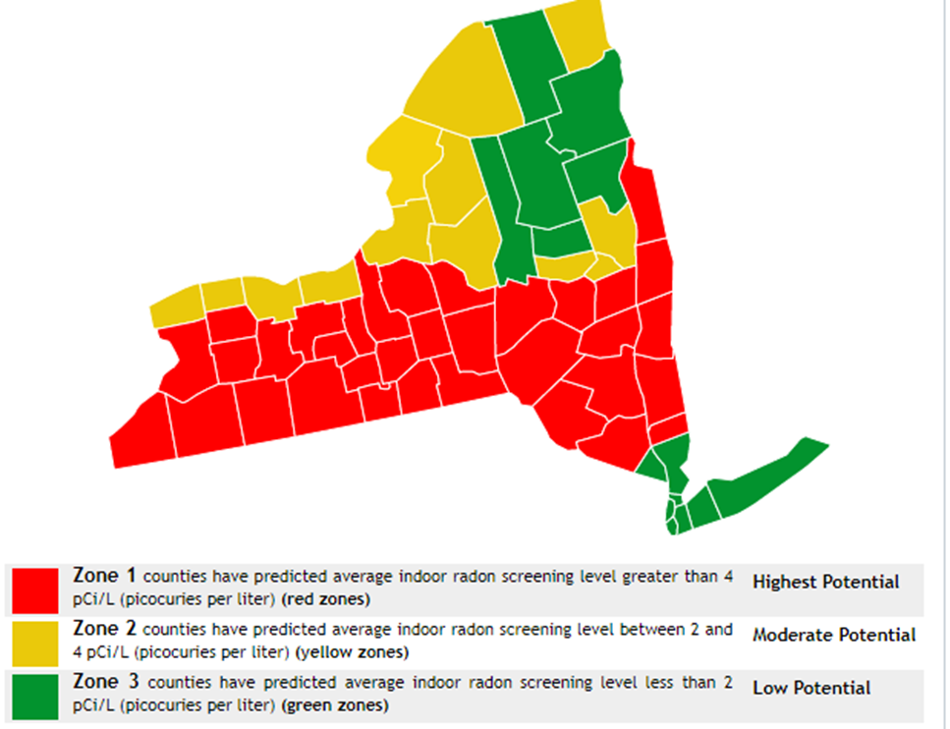
Tioga County is located in Zone 1, meaning this area has the highest levels of radon in the country. The average home in Tioga County contains 5.8pCi/L of radon. This is significantly higher than most of the country. Smokers who have elevated levels of radon in the home have a significant increase developing lung cancer, then non-smokers. The following chart compares radon levels to smoking cigarettes or having chest x-rays within a year.
Radon Level | Equal to
4.0 pCi/L | 200 Chest X-Rays or 2,920 cigarettes per year
8.0 pCi/L | 400 Chest X-Rays or 5,840 cigarettes per year
10.0 pCi/L | 500 Chest X-Rays or 7,300 Cigarettes per year
15.0 pCi/L | 750 Chest X-Rays or 10,950 Cigarettes per year
20.0 pCi/L | 1,000 Chest X-Rays or 14,240 Cigarettes per year
40.0 pCi/L | 2,000 Chest X-Rays or 29,200 Cigarettes per year
100.0 pCi/L | 5,000 Chest X-Rays or 73,000 Cigarettes per year

HOUSING STOCK
Within the Southern Tier Region, Tioga County has the second smallest amount of housing stock, 22,571 units. Of these units 91.5% are occupied, while 8.5% are vacant, which contributes to blight. The following chart breaks down the occupancy levels per town and village in Tioga County that are located closer to the area’s main employers and quality school districts.
Municipality | Occupied | Vacant
Apalachin | 98.1% | 1.9%
Town of Barton | 92.3% | 7.7%
Town of Owego | 94.9% | 5.1%
Town of Tioga | 93.5% | 6.5%
Town of Nichols | 90.7% | 9.3%
Village of Spencer | 94.6% | 5.4%
Village of Owego | 92.4% | 7.6%
Village of Waverly | 93.2% | 6.8%

This chart below depicts the municipalities with the lowest occupancy levels in the area. These towns/villages are those that are in the county’s rural areas. These areas are furthest away from major employers, and they also have the regions lowest ranked school districts.
Municipality | Occupied | Vacant
Village of Candor | 88.4% | 11.6%
Village of Newark Valley | 85.7% | 14.3%
Village of Nichols | 84.3% | 15.7%
Tow of Richford | 84.6% | 15.4%
Town of Newark Valley | 88.2% | 11.8%

Throughout the county, it is estimated that 77.9% of the homes are owner occupied, while 22.1% are occupied by renters.
Most Tioga County’s housing structures include one unit (71%), and 10.2% include two to four units. Significant percentages of housing units in several municipalities are renter occupied, which is of particular concern in the Village of Owego with 43%, the Village of Waverly with 45% and the Village of Spencer at 41%. In these municipalities, much of the rental property is in the form of single-family houses. Close behind is the village of Candor with 38.5%.

Tioga County also contains a high concentration of mobile homes; an estimated 14.4% of the housing structures are mobile homes, which is significantly higher than the New York State rate of 2.4% and the national rate of 6.4%. The highest concentration of mobile homes is in the town of Tioga with 660 mobile homes or 31.4% of the housing stock.
The housing stock throughout Tioga County and the remainder of the Southern Tier is also dated, “leading to an assumption that a portion of the stock is suffering from deferred maintenance and outdated construction materials such as inadequate wiring, use of lead-based paint, asbestos, roofing materials, poor insulation, and weatherization. Much of the housing stock also is lacking in upgrades that meet the expectations of today’s consumers, as well as amenities important to changing lifestyles, such as handicapped accessibility. Just over 200 units lack complete kitchen and plumbing facilities, and some 193 do not have access to telephone service. The median age of housing in Tioga County is 50 years, as compared to 37 years nationally. 30% of homes in Tioga County were constructed before 1949, and about 9,782 homes were built prior to 1960. The average year that homes were built is 1965, and only 7 housing units were constructed in 2014 or later. Tioga County’s housing stock consists of 3,335 mobile homes, which correlates to 15% of the total housing stock.

Types of Fuels Used
The majority of homes in Tioga County utilize fuel oil or kerosene, (29.3%) or utility gas (30.2%) as their primary source of heating fuel, while 14.4% use bottled, tank or LP gas; 12.0% use electricity; and 8.2% use wood. Meanwhile, 0.2% of households report using no fuel, while 1.1% use “other” fuel. Only 74 homes or 0.4% of home is Tioga County report using solar heat.

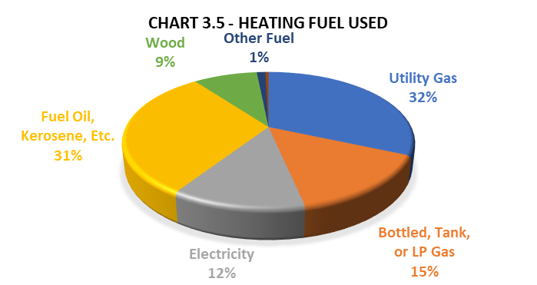

Income and Affordability
Further compounding the challenges of the housing market in Tioga County include the limited household income to buy or rent, as well as the lack of affordable housing to purchase or rent. The median household income in Tioga County is $61,695, meanwhile the living wage needed to meet basic needs for a household consisting of 2 working adults and 1 child is $74,380.
Table
Popular Market Area | # Of Homes for Sale | Median Listing Price
Apalachin | 40 | $122,450
Barton | 14 | $109,700
Candor | 47 | $89,900
Lounsberry | 19 | $94,900
Newark Valley | 43 | $94,250
Nichols | 20 | $102,400
Owego | 86 | $117,250

As construction material prices continue to rise, it poses another challenge to purchasing and maintaining a home. From January 2021 to January 2022, material costs rose by an average of 20% according to an analysis of government data. According to the Associated General Contractors of America (AGC), not only have material prices increased, but contractor labor rates have increased by 3.2%, this increase has skyrocketed over private sector jobs by 10.1%, with an average hourly pay for a contractor at $30.73, this contributes to higher costs for home repairs for homeowners who may not have the skills or knowledge to make the necessary repairs themselves and are forced to call a contractor.
These rising costs are causing homes to become neglected because repairs aren’t being made nor are homes being upgraded with newer energy efficient appliances, which leads to higher heating/electrical bills, further compounding the problem of home ownership. Most people aged 51 to 62 are in the low to moderate income level and live in single family homes and are unable to pay for home repairs without the financial resources to do so. As these homes go unrepaired, they can’t be sold which would free up homes for first time home buyers, so they contribute to blight throughout the community. Furthering the problem first time home buyers is the cost for flood insurance and property taxes, when combined, these are usually higher than a monthly mortgage payment. Flood insurance in Tioga County averages between $2,000 - $3,000 per year. As homeowners struggle to pay the mortgage and insurance, they don’t have the funds to make necessary home repairs, resulting in ongoing neglect of needed repairs.

Rental Assistance
The Tioga County Department of Social Services Section 8 unit assists numerous families with rental assistance in Tioga County. In 2022, there were 257 total rental vouchers available. These vouchers equated to a monthly average of $83,528. The total rental subsidies provided in 2022 to those families in need was $1,002,356. Roughly 72% of households receiving a Section 8 voucher had a female Head of Household, additionally about 75% of these households had a Head of Household who was over the age of 50 years old.

CHAPTER 6: EMPLOYMENT AND ECONOMY
Housing availability and affordability are key factors in the successful attraction and retention of both businesses and the strong employee base to help those businesses thrive. Likewise, viable businesses are necessary for the housing industry to succeed. They provide a necessary tax base, employment, and local services for residents. This last part is key when discussing transportation issues to areas outside residents’ immediate neighborhoods (see Transportation section).
While employers play a key role in shaping the community, the employment wages, and other socioeconomic factors of the area, play key roles as well.
Employers in the County
Tioga County’s 745 employers hail from many industries, from the small retail stores and breweries lining the main streets of our villages, to entertainment, healthcare, manufacturing, agriculture, and defense.
Currently, the two biggest employers in the county are Lockheed Martin, with approximately 2,800 workers, and our six area school districts, with approximately 1,460 employees.
The healthcare sector employs over 1,367 employees in the county, with almost half of them working in nursing and residential care facilities as personal care aides and nursing assistants. There are 395 employees at Elderwood and Riverview Manor alone. Government and social service agencies employ approximately 500 people.
Tioga Downs is the largest year-round entertainment and tourism employer, with a total of 550 employees. The warehousing and distribution sector employs workers at companies such as Best Buy (325 employees) and FedEx. Other larger employers include businesses such as Upstate Shredding (200), Stateline Auto (166), FS Lopke (200), Leprino Foods (230) and Crown Cork & Seal (105).

Industries and Occupations
TABLE 6.1 on the following page shows the primary occupations held by county residents. The most common occupations are Office and Administration Support (2,775 people), Management (2,425 people), and Sales and Related Occupations (1,742 people).
The highest paying jobs held by residents are Architecture and Engineering Occupations ($87,386), Legal Occupations ($83,132), Computer and Mathematical Occupations ($76,607), and Computer, Engineering, and Science Occupations ($75,491).

TABLE 6.2 on the following page depicts Tioga County employment by industry, which reveals that the most common employment sectors for residents are Manufacturing (3,614 people), Healthcare and Social Assistance (3,047 people), Educational Services (3,007 people), and Retail Trade (2,252 people).
The highest paying industries in Tioga County are Utilities ($58,750), and Professional, Scientific, and Technical Services ($57,829) and Public Administration ($52,927).
TABLE 6.1 – TIOGA COUNTY EMPLOYMENT BY OCCUPATION
Occupation | %
Office and Administrative Support | 12.3
Management | 10.7
Sales and Related Occupations | 7.7
Production | 7.3
Construction and Extraction | 6.9
Education and Library Instruction | 6.4
Food Preparation and Serving | 6.2
Building and Grounds Cleaning and Maintenance | 4.5
Computer and Mathematical | 4.0
Installation, Maintenance, and Repair | 3.9
Material Moving | 3.7
Architecture and Engineering | 3.6
Health Diagnosing, Treating, Practitioners and Other Technical | 3.3
Transportation | 3.2
Business and Financial Operations | 3.1
Personal Care and Service | 2.5
Healthcare Support | 2.4
Health Technologies and Technicians | 2.0
Community and Social Service | 1.9
Law Enforcement | 1.2
Life, Physical, and Social Science | 1.0
Art, Design, Entertainment, Sports, and Media | .5
Legal Occupations | 0.7
Source: Data USA, Tioga County Profile 2020

TABLE 6.2 – TIOGA COUNTY EMPLOYMENT BY INDUSTRY
Industry | %
Manufacturing | 16.2
Healthcare and Social Assistance | 13.7
Educational Services | 13.5
Retail Trade | 10.1
Construction | 7.8
Accommodation and Food Services | 7.0
Professional, Scientific and Technical Services | 6.7
Public Administration | 3.8
Administrative Support and Waste Management Services | 3.0
Wholesale Trade | 2.7
Transportation and Warehousing | 3.1
Finance and Insurance | 2.1
Real Estate & Rental Leasing | 1.4
Agriculture, Forestry, Fishing and Hunting | 1.4
Arts, Entertainment & Recreation | 1.1
Utilities | .8
Mining, Quarrying & Oil & Gas Extraction | .4
Source: Data USA, Tioga County Profile 2020

In addition to the target sectors, Tioga County has a strong agricultural heritage. The sector encompasses over one-third of the County’s landmass, generating over $36.7 million annually in local sales, resulting in closer to $100 million community dollars and employment for over 500 people.
In 2016-2020, an estimated 83% of Tioga County workers drove to work alone while 8.4% carpooled, and 4.5% worked from home. Among those who commuted to work, it took them 23.8 minutes, on average, to get to their place of work.
Workforce Decline
From 2019 to 2020, employment in Tioga County decreased at a rate of 1.06%, from 22,800 employees to 22,600 employees. This continues a downward trend since 2010, when the County had 26,588 people in the workforce.
It’s worth noting that not all Tioga County employers are staffed by those living within the county, and there is also outward migration of Tioga County residents who work outside Tioga County. However, the entire Southern Tier is experiencing the same workforce issues, as shown by Chart 6.3 below.

CHART 6.3 – Cumulative Labor Force Growth, Labor Market Regions in New York, Indexed to 2011
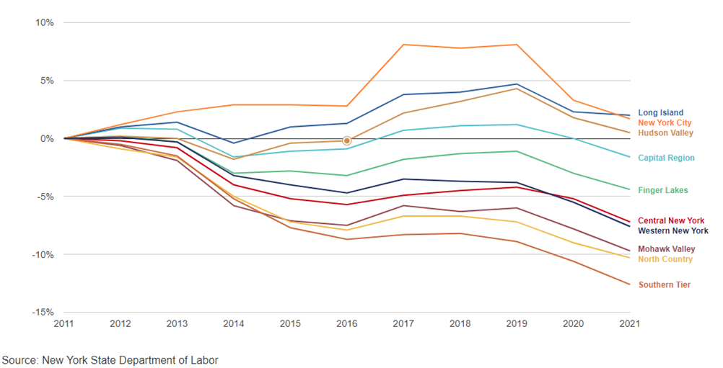

The (2022) 10-year trend report from NYS Office of the Comptroller notes “A factor influencing the labor force in the different regions of the State is population change, especially that of the working age population.” As shown in Chart 3.23 below, “the regions with the largest labor force decreases were those with the greatest population declines. Population grew in the regions that expanded their labor forces.”
Chart 6.4 Change in Labor Force & Population Aged 16 and Over by Labor Market Region, 2011 - 2021
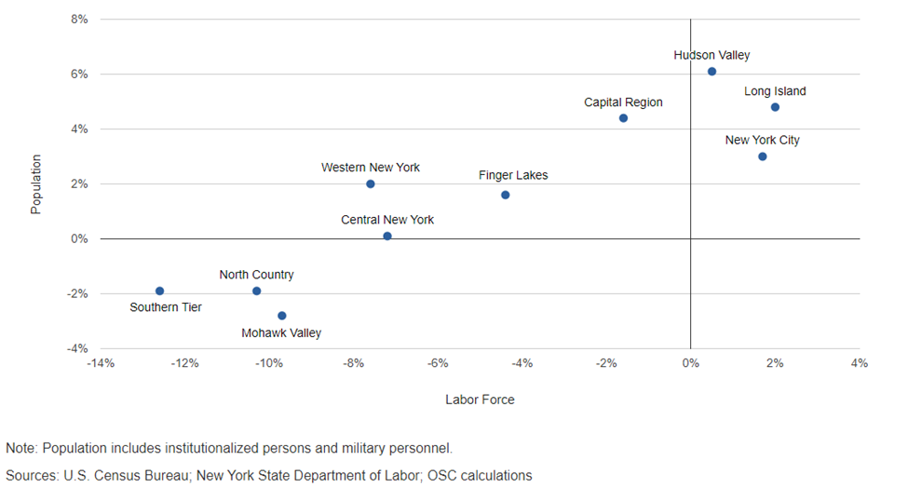

Effects of the Pandemic on Businesses
The COVID global pandemic (started March 2020) had a significant effect on local businesses. With people unable to be in person at restaurants and stores for so many months, businesses had to pivot to carry out services, and many didn’t survive. The Paycheck Protection Program created an opportunity for businesses to be reimbursed for payroll costs to retain employees, and Tioga County’s banks worked with many local businesses to assist with PPP loan applications and the ensuing loan forgiveness. According to the PPPDirectory, Tioga County businesses received a total of 391 loans, with a reported 4,165 jobs being retained.

“The Great Resignation”
According to the U.S. Bureau of Labor Statistics, in 2021 over 47 million Americans voluntarily quit their jobs — numbers never seen previously. While it seemed to be mostly a factor of the pandemic, due to the timing, many factors led to this cyclical downtown, including baby boomers retiring, the shrinking population of the Millennial and Gen Z demographics, parents having to stay home to educate children during the pandemic, and of course the losses from the pandemic. Forbes Magazine explained the reasons for this cyclical decline in November 2021:
“Even before the pandemic, a demographic “perfect storm” was brewing in developed labor markets, reducing talent availability at both the leadership and entry levels of organizations. Today, future-seeking leaders understand the varied factors creating talent shortages as they tackle the challenge.
The impact is pronounced in countries including the United States, United Kingdom, Canada, France, Germany, and the Netherlands. As large swells of Baby Boomers retire and Millennials move past entry-level roles, talent shortages among Generation X and Generation Z workers exacerbate what many are calling “The Great Resignation.”
Using the United States as an example, Willis Towers Watson’s analysis of U.S. Census and Bureau of Labor Statistics data shows the problem: Despite overall population growth (11.9%) and labor force growth (4.5%), the labor force shrank from 2010 to 2020 in age groups 16-24 (-3.4%), the historical entry-level talent pool, and 45-54 (-10.6%), the historical leadership talent pool. The data show the same result when analyzed from 2010-2019, demonstrating this problem originated before the pandemic.
The pandemic then drove down labor force participation rates (the proportion of the working-age population that is either working or actively looking for work) for these and other age groups, creating even more of a crunch. The resulting low supply of workers gave employees greater choice and “buying power,” increasing their ability to negotiate higher wages and more favorable benefits and work arrangements by changing jobs. Employers were not able to replace employees due to low workforce availability. Thus, the cycle of talent shortages and “The Great Resignation” was born.
While overall labor force participation rates may increase as economies emerge from the pandemic, labor economists anticipate even lower levels of participation in 2030 for workers under the age of 45. And because the 2030 labor force for age groups 16-34 and 55-64 is expected to be smaller than in 2020, the problem will not self-correct any time soon.”

Tioga County has mirrored the nation with the trends from pre-pandemic to post-pandemic unemployment rates. This has put a strain on county businesses trying to hire qualified candidates. As per Table 6.5 below, in August of 2019, Tioga County had an unemployment rate of 3.8%, and NY State had an unemployment rate of 4.0%. During 2020, the COVID pandemic caused the unemployment rates to rise exponentially. This was followed by plummeting unemployment rates in the county, state, and nation, as people were called back to work, and the ‘Great Resignation’ caused a major shortage of workers. In August of 2022, Tioga County’s unemployment rate was at 3.2%, with New York’s overall at 4.9%. Tioga County also has a low unemployment rate compared to other counties in NY state (Chart 6.6).
CHART 6.5 Unemployment rates by area, 2019-2022 (August of each year)
 | 2019 | 2020 | 2021 | 2022
Tioga County | 3.8% | 6.6% | 4.2% | 3.2%
NY State | 4.0% | 10.9% | 6.7% | 4.9%
Nation | 3.8% | 8.5% | 5.3% | 3.8%
Source: New York State Department of Labor (https://dol.ny.gov/local-area-unemployment-statistics)

MAP 6.6 – Unemployment Rates by County, New Yor State, August 2022
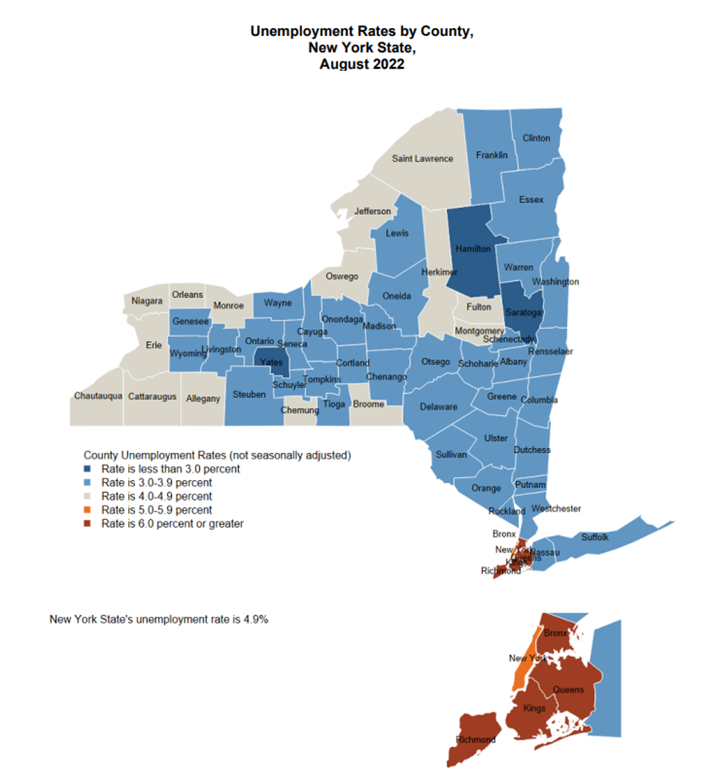

Employers are, therefore, trying to find ways to attract the (fewer) people available in the workforce. They are offering more unique benefits and retention incentives, increasing pay rates, and to increasing flexibility with both remote work and flexible scheduling.
Tioga County Economic Development & Planning has been fostering partnerships with schools to tap that talent before we lose it out of the county: “The 2020-2025 Tioga County Workforce Development Strategy is Tioga County’s response to facilitate connections between and among local school districts, higher learning institutions, and local and major employers. The strategy outlines a roadmap to realize a highly qualified and skilled talent pipeline that supports alignment with local employer needs.”
Wages and Income
The median household income of Tioga County ($61,965) is less than the living wage needed to meet basic needs ($74,380). This difference ($12,415) is less than all surrounding counties and New York State as a whole (TABLE 6.7). However, it’s still a significant difference, and the living wages have climbed a lot faster than the median household income. In 2017, the living wage in Tioga County for this same family composition was $57,706, but the median was $57,153. According to the U.S. Census, an estimated 4.3% of households had income below $15,000 a year, while 32.9% had incomes over $100,000 (TABLE 6.8).
TABLE 6.7 – LIVING WAGE ESTIMATE AND MEDIAN HOUSEHOLD INCOME BY COUNTY, 2020
County | Living Wage Needed to Meet Basic Needs (2 adults both working, 1 child) | Median Household Income | Difference between Income and Cost of Basic Needs
Broome | $74,380 | $52,237 | -$22,143
Chenango | $73,466 | $51,756 | -$21,710
Delaware | $73,050 | $49,945 | -$23,105
Otsego | $75,504 | $56,171 | -$19,333
Tioga | $74,380 | $61,965 | -$12,415
NYS | $92,019 | $71,117 | -$20,902
Sources: Livingwage.mit.edu
Data USA Tioga county profile, 2020

TABLE 6.8 – HOUSEHOLD INCOME IN TIOGA COUNTY IN 2016-2020
Income | %
Less than $10,000 | 2.6%
$10,000 - $14,999 | 1.7%
$15,000 - $24,999 | 4.4%
$25,000 - $34,999 | 8.1%
$35,000 - $49,999 | 12.4%
$50,000 - $74,999 | 20.3%
$75,000 - $99,999 | 17.5%
$100,000 - $149,999 | 19.4%
$150,000 - $199,999 | 8.9%
$200,000 or more | 4.6%
Source: 2016-20 American Community Survey, 5-Year Estimates

Poverty and ALICE Rates
In 2020, 9.89% of the population for whom poverty status is determined in Tioga County, NY live below the poverty line, a number that is lower than the state average of 13.6%, and the national average of 12.8%. The largest demographic living in poverty are Females 18 - 24, followed by Females 75+ and then Males 25 - 34.
CHART 6.9: POVERTY BY AGE AND SEX
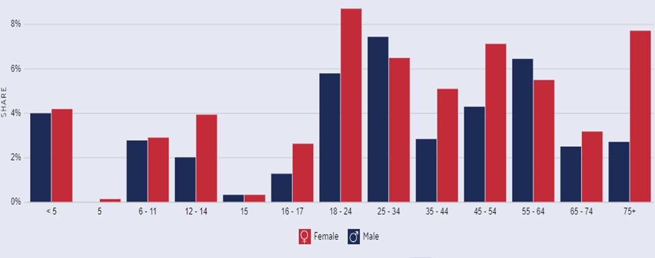
TABLE 6.10 – PERCENTAGE OF ALICE + POVERTY HOUSEHOLDS IN TIOGA COUNTY, 2018 Source United Way ALICE Report
Town | Total HH | % ALICE + Poverty
Apalachin | 528 | 45%
Barton town | 3,287 | 49%
Berkshire town | 443 | 40%
Candor village | 274 | 42%
Candor town | 1,939 | 34%
Newark Valley vill. | 388 | 43%
Newark Valley twn | 1,455 | 29%
Nichols village | 202 | 35%
Nichols town | 1,012 | 35%
Owego village | 1,703 | 46%
Owego town | 7,914 | 30%
Richford town | 438 | 39%
Spencer village | 334 | 43%
Spencer town | 1,273 | 44%
Tioga town | 2,284 | 45%
Waverly village | 1,702 | 56%

While poverty in Tioga County, as defined by federal guidelines, might be lower than the state and federal levels, it doesn’t tell the whole picture. We also must consider those who are technically above this line but are not able to thrive.
We all know people who are ALICE -Asset Limited, Income Constrained, Employed. ALICE workers educate our children, keep us healthy, and make our quality of life possible, yet do not earn enough to support their own families. ALICE households are forced to make tough choices, such as deciding between quality childcare or paying the rent, which have long-term consequences not only for ALICE, but for all.
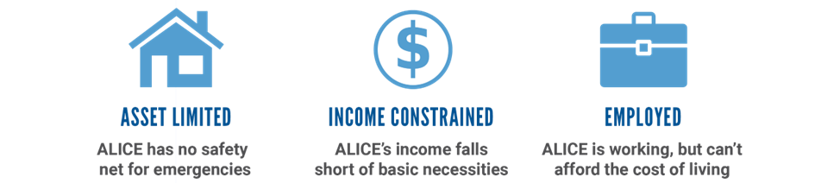
In Tioga County in 2018, 26% of households fall into the ALICE threshold. They are above the poverty line, but not making adequate wages to meet basic needs. Table 3.29 shows the percentage of ALICE + poverty households in Tioga County by municipality. Chart 3.30 shows the number of ALICE households over time.
CHART 6.11 – NUMBER OF ALICE HOUSEHOLDS OVER TIME
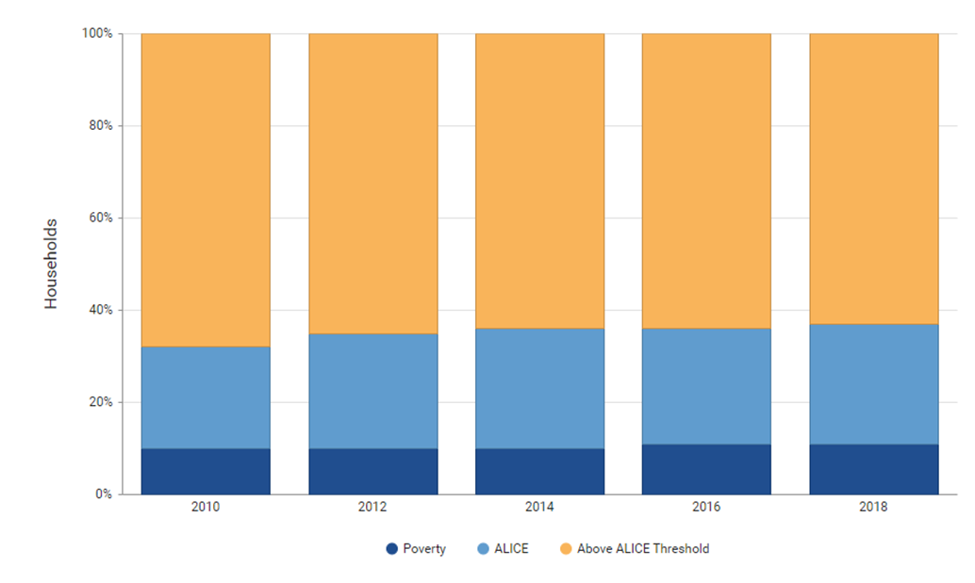
HEAP, SNAP, and Medicaid Participation
The HEAP (Home Energy Assistance Program) is a vital program that helps low-income people pay the cost of heating and heating/cooling repair costs in their homes. The 2019-2020 HEAP season ran from October 1, 2019, through September 30, 2020. The HEAP Unit processed 6,046 benefits (and increase of 2% over the previous season) resulting in allocations of $3,002,578 or an average of $496 per benefit. As fuel prices continue to climb in 2021-2022, it will no doubt have an impact on the average benefit amount required.
Within Tioga County, the SNAP, and Medicaid Unit (FSMA) manages the applications and under-care for those requiring assistance with food stamps and Medicaid coverage. SNAP issues monthly electronic benefits to individuals and families that can be used like cash to purchase food at authorized retail food stores and farmers’ markets. Eligibility and benefit levels are based on household size, income and other factors. Medicaid is an income and resource-based program available for individuals who need coverage for their medical expenses. In 2020, FSMA processed 18,323 applications, re-certification, and under-care maintenance tasks, which is down from 23,467 in 2018. The average monthly number of individuals receiving SNAP benefits in 2020 was 4,604, including approximately 1,540 children. This number is down slightly from 4,970 in 2018.
The monthly average of Tioga County residents on Medicaid in 2020 was 10,562. 3,684 of these cases continued to be managed by the FSMA staff, the others are on the NY state exchange. 1,198 residents received Social Security Income every month on average, while there were 229 Chronic Care Medicaid cases.

CHAPTER 7: EDUCATION
Educational Attainment
In Tioga County, of people 25 years and over, 91.8% had graduated high school or higher, whereas 8.2% of residents 25 years and over did not complete high school. As of 2020, 33% of the adult population, aged 25 years or older, in the United States has a bachelor’s degree or higher. As shown below, the rate of adults with a bachelor’s degree or higher in Tioga County is much less than the general population.
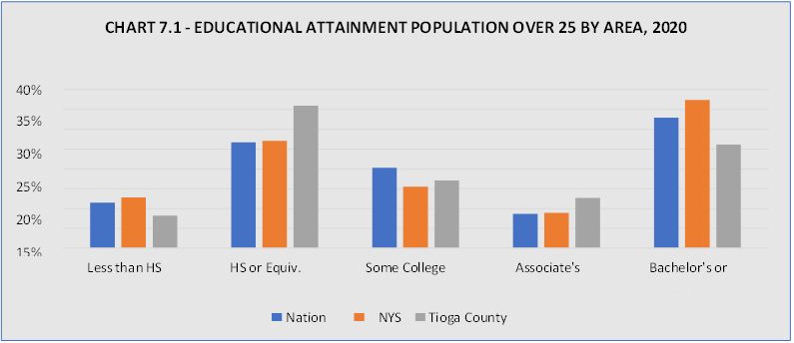
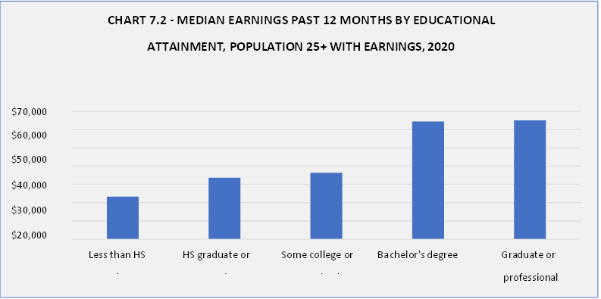
In 2020, the rate of people aged 18 to 24 with less than a high school diploma was 14.8% compared to 2017 at 13.6%. Since 2017, the rate of those aged 18 to 24 with a bachelor’s degree or higher increased from 9.4% in 2017 to a high of 12.8%. The following table depicts these historical trends.
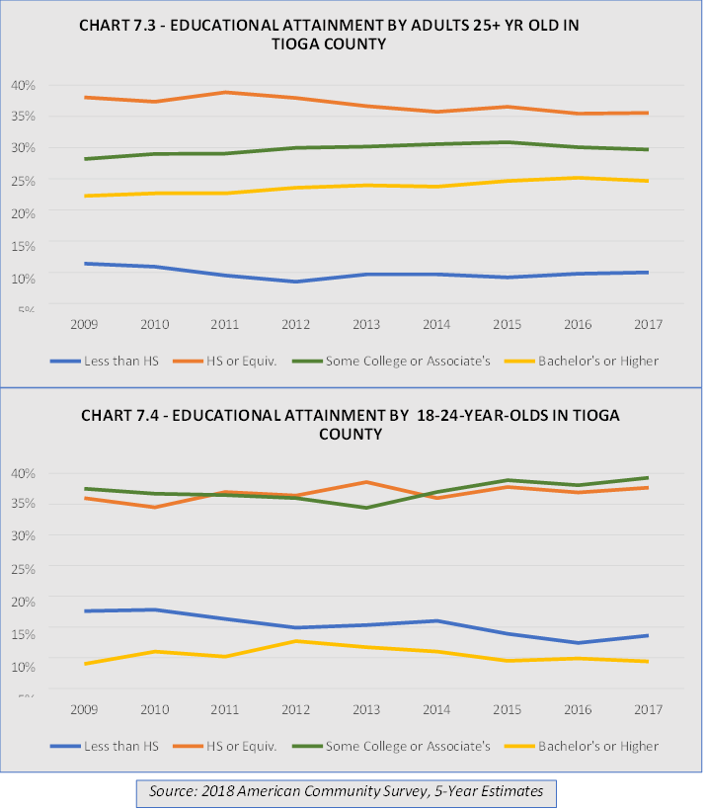

Student Enrollment
There is one private school in Tioga County, the North Spencer Christian Academy, which serves students in grades K-12; compared to the six public schools in Tioga County: Candor, Newark Valley, Owego-Apalachin, Spencer-Van Etten, Tioga, and Waverly Central School District. The total enrollment of K-12 public students in 2020-2021 was 6,600, which was lower than the previous two academic years (2019-2020 of 6,874 and 2018-2019 of 6,898). The following table illustrates student enrollment by public school and homeschool instruction in Tioga County.
TABLE 7.5 – STUDENT ENROLLMENT BY PUBLIC SCHOOL AND NON-PUBLIC ENROLLMENT, 2020-2021
School District | Public School Students | Non-Public Students | Total Students
Candor | 714 | 8 | 722
Newark Valley | 1,007 | 10 | 1,117
Owego-Apalachin | 1,827 | 58 | 1,885
Spencer-Van Etten | 760 | 50 | 810
Tioga | 881 | 1 | 882
Waverly | 1,411 | 14 | 1,425
TOTAL | 6,600 | 141 | 6,841
Sources: New York State Education Department and Tioga County Public Schools, 2020-2021

School Quality and Student Performance
Many studies have found that schools are considered good if they contain updated facilities and equipment, stimulating atmospheres, high-quality educational programs, as well as if they are safe, have dedicated teachers, small class sizes, healthy environments, and graduates who go on to excel academically and occupationally. However, researchers have found that the determining factor in decisions of where to attend school was whether the school was located in a good neighborhood.
This relationship between quality school districts and housing buying behavior has long been documented. According to the National Association of Realtors 2021 Home Buyers and Sellers Generational Trends, 24% of home buyers listed school quality and 23% listed proximity to schools as deciding factors in their home purchase.

This is complemented by a study by Housing Matters, an Urban Institute Initiative, which shows families take on greater increases in their monthly housing costs to gain access to better schools for their children, especially in metro regions with greater income inequality. Local data indicates that Tioga County falls in line with these trends as clear linkages exist between areas with the lowest occupancy and highest vacancy rates and the region’s lowest ranked school districts (Candor, Newark Valley, and Spencer).
The following table displays the ratings of Tioga County public school districts by GreatSchools, which includes important information in addition to test scores – factors that make a big difference in how children perform in school, such as how much a school helps students improve academically and how well a school supports students from different socioeconomic groups.
TABLE 7.6 - AVERAGE RATINGS OF PUBLIC SCHOOLS IN TIOGA COUNTY, 2022
Public School District | Overall Ranking | Academics |  | Equity |  | Student to Teacher Ratio
 |  | Test Scores* | Student Progress* | Equity Overview* | Low- Income  Students*
Candor | 5 | 4 | 7 | 3 | 7 | 10:01
Newark Valley | 5 | 6 | 3 | 4 | 2 | 12:01
Owego-Apalachin | 6 | 7 | N/A | 5 | N/A | 12:01
Spencer | 4 | 5 | N/A | 3 | N/A | 12:01
Tioga | 7 | 8 | N/A | 7 | N/A | 12:01
Waverly | 4 | 6 | N/A | 4 | N/A | 16:01
Source: GreatSchools Rankings; based on senior high schools
Ratings at the lower end of the scale (1-4) signal that the school is “below average,” 5-6 indicates “average,”
and 7-10 are “above average.”
*Test Score measures schools on proficiency, using performance on state assessments across grades and subjects compared to other schools in the state
*Student Progress measures the level of progress students have made on reading and math assessments during the past year or more
*Equity Overview measures how well a school serves the academic development of all students by examining the performance level of disadvantaged students on state tests and in-school performance gaps between disadvantaged students and other students
*Low Income Rating measures state test scores for students who qualify for free or reduced-price lunch
compared to all students in the state

The above rankings in Table 7.6 show that among Tioga County senior high schools, two of the schools are below average, three are average, and only one is above average. In past survey and focus groups, participants overwhelmingly believed Tioga County offered good schools and that this was a strong asset to living in the county. Specifically, during discussions with Tioga County residents, parents remarked how the dedication and longevity of school staff, additional social support, small class sizes, and safety were factors contributing to the county’s public school quality. Some schools did not have updated ranking scores for their high schools. It is possible some of this data is incomplete due to COVID-19 and the associated upheaval of school operations.
Absenteeism
Within Tioga County schools and throughout the nation, chronic absent students (those who miss at least 15 days of school in a year) usually face tremendous adversity – including poverty, health challenges, community violence, and difficult family circumstances – that make it difficult for them to take advantage of the opportunity to learn at school. Within Tioga County, roughly 14% (or 992 out of 6,874) of the student population was chronically absent in the 2017-2018 school year compared to about 18% statewide. The largest rate of chronic absenteeism occurred at Waverly Central School District at 24.8%, whereas the lowest rate took place at Newark Valley at 14.5%. See TABLE 3.28. It is worth noting that Spencer-Van Etten and Waverly both have high percentages of chronically absent students and have the lowest rankings in TABLE 3.27. Updated data is not currently available, possibly due to the upheaval of school operations during the COVID-19 pandemic.
TABLE 7.7 – PERCENT OF CHRONICALLY ABSENT STUDENTS IN TIOGA COUNTY,
2017
School District | % | #
Candor | 15.7% | 113
Newark Valley | 14.5% | 168
Owego-Apalachin | N/A | N/A
Spencer-Van Etten | 18.6% | 178
Tioga | 15.0% | 145
Waverly | 24.8% | 388
TOTAL |  | 992
Source: Civil Rights Data Collection

Suspension and Expulsion
The following table displays disciplinary data of Tioga County public schools in 2017. As shown below, Newark Valley Central School District has the highest percentage (11.8%) of students with disabilities with an in-school suspension, followed by Owego-Apalachin (8.8%). Spencer-Van Etten has high percentages of students with in-school and out-of-school suspensions. Tioga Central School and Newark Valley are the only districts in which referral to law enforcement occurred. Tioga Central School also had the highest rate (9.1%) of students with one out-of-school suspension. Updated data is not currently available, possibly due to the upheaval of school operations during the COVID-19 pandemic.
TABLE 7.8 – DISCIPLINARY DATA IN TIOGA COUNTY PUBLIC SCHOOLS, 2017
School | Enrollment | In-School Suspensions |  | One Out-of- School Suspensions |  | Expulsions  w/Ed Service |  | Students Referred to Law Enforcement |  | Students with School- Related  Arrests
 |  | W/O Dis. | W/ Dis. | W/O Dis. | W/ Dis. | W/O Dis. | W/  Dis. | W/O Dis. | W/ Dis. | W/O Dis. | W/  Dis.
Candor | 722 | 5.2% | 2.9% | 2.8% | 1.9% | 0% | 0% | 0% | 0% | 0% | 0%
Newark  Valley | 1,159 | 2.5% | 11.8% | 0.9% | 4.2% | 0% | 0% | 0.1% | 0% | 0% | 0%
Owego-  Apalachin | 1,954 | 4% | 8.8% | 1.7% | 5.6% | 0% | 0% | 0% | 0% | 0% | 0%
Spencer-  Van Etten | 955 | 6.8% | 8.3% | 2.5% | 6.1% | 0% | 0% | 0% | 0% | 0% | 0%
Tioga | 967 | 3.3% | 2.6% | 2.2% | 9.1% | 0% | 0% | 0.1% | 2.6% | 0% | 0%
Waverly | 1,565 | 4.2% | 5.5% | 2.1% | 3.5% | 0% | 0% | 0% | 0% | 0% | 0%
Source: Civil Rights Data Collection School and District Search

Free and Reduced Lunch
The percentage of students receiving free and reduced lunch is often used as a proxy measure for the percentage of students living in poverty. In Tioga County, the highest rates of free and reduced lunch within elementary schools were at Spencer-Van Etten (62.7%), followed by Candor (52.4%).
Within county high schools, the highest rates were at Tioga (62.8%) and Spencer-Van Etten (52.8%). The table below further illustrates these rates. Candor, Newark Valley, Owego-Apalachin, Tioga, and Waverly all had decreased percentages from the 2018-2019 school year, whereas Spencer-Van Etten had an increase of 7.1%.

TABLE 7.9 – FREE AND REDUCED LUNCH RATES IN
TIOGA COUNTY SCHOOLS, 2018-2019
School | Elementary | Middle | High
Candor | 52.4% | 54.9%
Newark Valley | 50.0% | 53.4% | 41.8%
Owego-Apalachin | 42.0% | 44.4% | 41.2%
Spencer-Van Etten | 62.7% | 60.3% | 52.8%
Tioga | 50.0% | 55.7% | 62.8%
Waverly | 47.2% | 45.5% | 34.9%
Source: SchoolDigger
Graduation Trends
The 2020-2021 overall graduation rate data in Tioga County shows graduation (92%) and regents (51%) as higher than the New York State averages of 86% and 42%, respectively. By contrast, advanced regents for Tioga County (39%) were lower than the state average (42%), and the dropout rate was the same at 4%. Further analysis reveals educational disparities between and within Tioga County’s school districts, as shown by TABLE 7.10 below. Every school district showed improvement in graduation rates from 2018 for every category except for Tioga students with disabilities, which saw a 1% decrease. It is possible these changes may be influenced by the change in school operations as a result of COVID-19.

TABLE 7.10 – GRADUATION RATE 2021
 | New York State | County- Wide | Candor | Newark Valley | Owego- Apalachin | Spencer-  Van Etten | Tioga | Waverly
All Students | 86% | 92% | 95% | 92% | 96% | 83% | 94% | 88%
Female | 90% | 94% | 95% | 94% | 97% | 88% | 93% | 91%
Male | 83% | 90% | 95% | 90% | 96% | 79% | 94% | 86%
General Education Students | 91% | 95% | 98% | 96% | 97% | 88% | 98% | 91%
Students with Disabilities | 64% | 75% | 80% | 67% | 90% | 63% | 75% | 73%
Non-  Economically Disadvantaged | 91% | 96% | 100% | 95% | 98% | 91% | 96% | 94%
Economically Disadvantaged | 81% | 86% | 88% | 87% | 93% | 78% | 91% | 77%
Source: New York State Education Department

Spencer Van Etten Central School District has the poorest graduation rates of all students in Tioga County, while Owego-Apalachin has the highest rate, followed by Candor and Tioga Central. The greatest variation in student graduation rates between schools is seen with Spencer Van-Etten and Owego-Apalachin at 13%. TABLE 7.10 displays this data, where green cells highlight performance that is better than the state average, and red cells are considered worse.

Educational disparities can be seen among separate demographic groups within schools. For example, more females than males graduate in each school except Tioga Central. The greatest variation in graduation rate by sex within school districts is seen at Spencer-Van Etten, where females graduate at a 9% higher rate than males. County-wide students with disabilities graduate at a 20% lower rate than their general education student counterparts. This rate is 11% higher than the New York State rate of 64%. Spencer Van-Etten is the only school district in Tioga County where students with disabilities graduate at a lower rate than that of New York State. There is a graduation rate gap between non-economically disadvantaged and economically disadvantaged students in Tioga County school districts. While the gap in New York State between these two groups is 10%, Candor, Newark Valley, Tioga, and Owego-Apalachin students fare better. Notably, Waverly has a 17% graduation rate difference and Spencer-Van Etten a 13% between students who are economically disadvantaged and those who are not economically disadvantaged.
Additionally, under the “4+1” pathway assessment option, graduating students’ interest in the Arts, Biliteracy (LOTE), Career and Technical Education (CTE), Career Development and Occupational Studies (CDOS), Humanities (HUM), and Science, Technology, Engineering and Math (STEM) are demonstrated through the successful performance of four required Regents Exams or Department-approved alternative assessments, as well as completion of a comparably rigorous pathway to meet the fifth requirement for graduation. In Tioga County public schools, pathways offered include the HUM, CTE, STEM, and CDOS. The following graphic illustrates the process graduating students must undertake to follow an approved pathway.
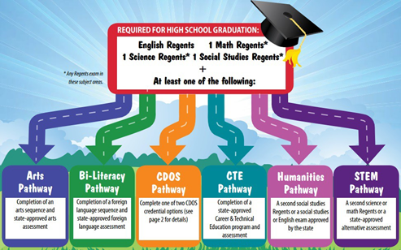

As shown by TABLE 7.11 on the following page, most graduating students (94%) in 2021 satisfied curriculum necessary for the Humanities pathway, and 6% of graduating students satisfied curriculum for Career and Technical Education. No students pursued Math and Science curriculum, and only 1% of students with disabilities pursued Career Development and Occupational Studies. This may reflect changes to school operations during the COVID-19 pandemic.

TABLE 7.11 – TIOGA COUNTY GRADUATION PATHWAYS DATA, 2020-2021
GROUP | HUM | CTE | MATH | SCIENCE | CDOS | TOTAL
All Students | 94% | 6% | 0% | 0% | 0% | 520
Female | 97% | 3% | 0% | 0% | 0% | 252
Male | 91% | 8% | 0% | 0% | 0% | 268
Students with Disabilities | 85% | 13% | 0% | 0% | 1% | 67
General Education Students | 96% | 4% | 0% | 0% | 0% | 453
Not Economically Disadvantaged | 96% | 4% | 0% | 0% | 0% | 310
Economically Disadvantaged | 92% | 8% | 0% | 0% | 0% | 210
Source: New York State Education Department

Economically disadvantaged students outperformed not economically disadvantaged students in CTE; whereas more not economically disadvantaged students pursued Humanities than economically disadvantaged students. Students with disabilities were much more likely to pursue CTE and CDOS than general education students, whereas general education students were much more likely to pursue Humanities curriculum than students with disabilities.
Humanities is a more specialized field, suggesting that students graduating under these pathways are likely to pursue higher education whereas those in CTE and CDOS fields are more likely to enter the workforce upon graduation. The fact that no students pursued Math and Science and only 1% of students with disabilities pursued CDOS is an interesting change from historical data.
Dropout Rates
The following table displays the dropout rate data for Tioga County schools across different demographic groups and in contrast with New York State rates. Overall, Tioga County schools reflect similar dropout rate trends in most every demographic group, yet students with disabilities in Tioga County are 4% more likely to dropout than the New York State population. Owego- Apalachin, Candor, and Tioga all have better overall dropout rates than the state. Spencer-Van Etten and Waverly school districts both have higher dropout rates across all categories as compared to NYS. Dropout rates are very high for students with disabilities and economically disadvantaged students at Waverly Central School District than students of the same groups at other schools.

TABLE 7.12 – DROPOUT RATES 2021
 | New York State | County- Wide | Candor | Newark Valley | Owego- Apalachin | Spencer-  Van Etten | Tioga | Waverly
All Students | 4% | 4% | 2% | 5% | 1% | 6% | 2% | 10%
Female | 3% | 4% | 0% | 4% | 1% | 6% | 3% | 9%
Male | 5% | 5% | 5% | 6% | 1% | 6% | 0% | 11%
General Education Students | 4% | 3% | 0% | 4% | 1% | 5% | 2% | 7%
Students with Disabilities | 7% | 11% | 10% | 13% | 5% | 13% | 0% | 27%
Non- Economically Disadvantaged | 2% | 1% | 0% | 2% | 0% | 3% | 0% | 3%
Economically Disadvantaged | 6% | 8% | 4% | 10% | 3% | 8% | 3% | 23%
Source: New York State Education Department

CHAPTER 8: TRANSPORTATION
The lack of transportation is a concern continually expressed by residents of Tioga County. Regularly accessing resources, whether it is a grocery store, human services, employment, or a doctor's office, is a consistent need experienced by many individuals in the community. Currently, Tioga County does not maintain or operate a bus system, leading residents to rely on family, friends, taxis, and volunteer transportation services. The transportation burden was exacerbated throughout the COVID-19 pandemic, as many volunteer transportation programs significantly limited services and informal support systems weren’t as readily available due to concerns of virus transmission.
According to the Rural Health Network of South-Central New York, “One of the main barriers to reducing the physical isolation of rural communities is transportation. Having access to consistent, reliable, and safe transportation is a primary barrier to the accessibility of healthcare, nutritious food, and other essential services.” In both rural and urban settings, transportation clearly impacts the usage of health care services because those without reliable transportation are more likely to delay and forgo necessary appointments, preventative care, and health maintenance activities. Transportation in rural America is often hard to access for older adults. “Millions of older adults living in rural America no longer drive and don’t have adequate access to alternative transportation that can assist them with rides to banks, pharmacies, and other important places,” said Baruch Feigenbaum, senior managing director for transportation policy at the Reason Foundation. “Many of those older adults can’t physically drive anymore, don’t want to drive or simply can’t afford a private vehicle, meaning they rely on friends or loved ones to get around, according to rural transit experts.”
Commuting to Work
Employees in Tioga County, NY have a shorter commute time (23.8 minutes) than the normal U.S. worker (26.9 minutes). “Super commutes,” defined as travel longer than 90 minutes, are present for only 1.64% of the workforce in Tioga County. In 2020, 83% of workers in Tioga County drove alone to work (almost identical to 2017 data showing 83.6% drove alone), followed by those who carpooled to work (8.43%--a decrease from 9.75% in 2017) and those who worked at home (4.48%). Although “residents working at home” increased from 2.62% in 2017, the data reported will likely show an increase in future reports due to those working remotely during the COVID-19 pandemic.

*Source: Data USA
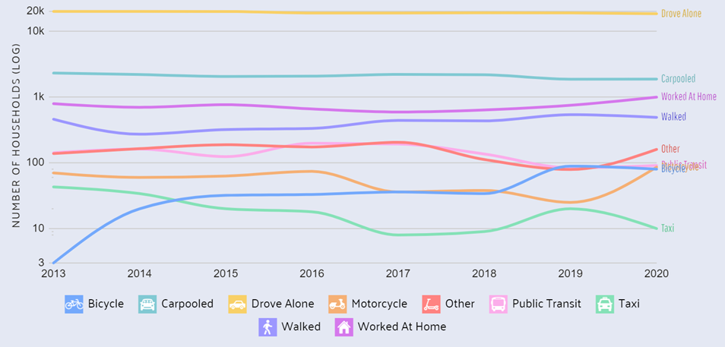

According to statistics taken from Data USA, it is evident that the number of Tioga County residents carpooling or driving alone to work has remained steady. The slight increase in those working from home is reflected in the graph above. Since 2013, the largest fluctuations in data exist in those bicycling or using taxis to travel to work.
Vehicle Ownership
The Rural Health Network of South-Central New York reports that “For many people in South Central New York, especially those in rural communities, car ownership is either cost prohibitive, or places a significant burden on the household’s ability to meet other essential needs.” According to the American Community Survey, 5-year estimates (2016-2020), most households in Tioga County have two cars (37.7%). 32% of households have just one vehicle available, while 5.8% have zero vehicles. 5,057 housing units, or 24.5% of Tioga County’s population, have three or more vehicles available.
Transportation-Vulnerable Populations
The Binghamton Metropolitan Transportation Study reports that as the number of older adults increases, there is an increased need for more specialized services beyond those typically provided through general public transit or shared ride human service agency-provided transportation. According to the National Aging & Disability Transportation Center, “As the nation’s aging population continues to rise – with 1 in every 5 Americans expected to be 65+ by 2020 – the provision of safe and accessible transportation options remains a top concern of older adults, caregivers, and the communities where they live….Accessible transportation services are critical for enabling older adults to live independently.
Without accessible, reliable, and affordable transportation, many more older adults could face the possibility of placement in a long-term care facility.” Recent data from the Rural Health Network of South-Central New York’s Getthere program reflects that the average age of callers seeking mobility management assistance from Tioga County is 64.75 years. The lack of transportation is also one of the most important issues facing rural socially disadvantaged people (referred to as transportation disadvantaged). The Rural Health Information Hub reports that “People with disabilities also experience transportation barriers. According to 2016-2020 data from the American Community Survey, the disability rate is 14.9% in rural communities, which is higher than the disability rate in metropolitan areas. People with disabilities living in rural communities often face challenges accessing and using various modes of transportation, which can impact health and quality of life.”
The Rural Health Network’s Getthere program reported a somewhat consistent trend in individuals contacting the agency for mobility management assistance. 253 cases were handled in 2020, 381 cases in 2021 (although this is considered an outlier as this figure is inflated due to COVID vaccination transportation assistance), and 274 cases in 2022. The most commonly stated need by those contacting the Getthere program is transportation to medical appointments, followed by transportation to employment. Rural Health Network’s “Transportation to Employment” program reported 38 referrals in 2022; of those, 21 received transportation assistance and six reached 90 days of employment.
Modes of Transportation
Analysis from the National Household Travel Survey reports that automobile, walking, public transit, and bicycling are the most common forms of travel in the nation. Specifically, 85% of all trips reported by individuals 19 years and older were made by automobile, while walking encompassed 10%, public transit 2.3%, and bicycling 0.7%
The National Aging & Disability Transportation Center states that “There is no universally accepted age at which people are no longer safe drivers, even though chronic conditions, and disability, which occur more frequently in old age, certainly impact that skill. The United States is a highly mobile culture, valuing the independence to go where you want and when you want to go. It’s no wonder, then, that the impact of having to “give up the keys” is a major, often negative, life event for many older adults.
But the impact can be lessened considerably if alternatives to driving are readily available and accessible.”
Alternative transportation options for older adults often consist of family and friends, nonmotorized travel (e.g., walking and biking), and private and public transportation alternatives. Stakeholder interviews conducted as a component of the Tioga Tells: Quality of Life Assessment (2018-2019) suggest that, in Tioga County, many older adults and residents with low income rely heavily on those within their social networks to fulfil their mobility needs. During these interviews, older adults in Tioga County highlighted the lack of sidewalks, poor upkeep, obstruction problems, and safety concerns as complaints associated with nonmotorized travel.
Community transportation options often include such services as:
• Dial-a-ride which offers curb-to-curb service at an agreed-upon time.
• Volunteer transportation programs; and
• Assisted transportation (called “door-to-door” or “door-through-door”) for older adults who need more than a ride, providing assistance from the door to the car or an “escort” to stay with them throughout the trip.
Such programs are typically funded with a combination of federal, state, and local funds. The Federal Transit Administration’s Section 5310 Program and Title III B of the Older Americans Act are two federal funding sources that frequently support such programs, including those at Tioga Opportunities, Inc.
Additionally, taxi and public bus services are common transportation alternatives available. There has been a loss of public transit in Tioga County since 2014. Ride Tioga, which provided fixed route public transit and dial-a-ride paratransit services, ceased operations on November 30, 2014. Ride Tioga operated for approximately 20 years in Tioga County. Funded with Federal Transit Administration and New York State Department of Transportation transit funds, as well as Medicaid transportation reimbursements, the service was at almost no cost to Tioga County. During 2013, New York State contracted with Medical Answering Services (MAS) to schedule all Medicaid transportation statewide. MAS assigned most patients to taxi service instead of the bus. Ride Tioga ridership, which had been rising annually, went from about 1,000 per month to zero in early 2014. The cease in operations of Ride Tioga left a significant gap in Tioga County transportation services, not only to Medicaid patients, but to those non-Medicaid riders who used the fixed route and paratransit services to get to work, medical appointments, food shopping, and more.

Transportation Programs and Services
In Tioga County, several transportation programs exist in the community which provide a needed alternative to public transit. Most programs are available through nonprofit groups, while others are volunteer- led. Most transportation services are for medical transport, leaving a gap in services to places like the pharmacy and recreational activities. The available programs typically provide door-to-door services (where an individual is picked up from their location and delivered to the destination’s door) or door-through-door transportation (where an individual is picked up and the transporter stays during the appointment). Some programs also offer a mileage reimbursement for volunteers. The following is a list of the available transportation programs in Tioga County:
Public Transit:
C-Tran | 607-734-5211 | Owego: 3x/day; Waverly: 4x/day

Public Transportation:
Owego Taxi | 607-687-1171 | Transports from Tioga Co. to surrounding counties
A&D Transport | 607-433-1726
Totem Taxi | 607-734-6161 | Elmira based; Tioga Co. not preferred

Paratransit Services:
Achieve | 607-723-8361

Volunteer Services:
Tioga Opportunities, Inc. | 607-687-4222
Northern Tioga Neighbors Network | 607-657-2823

Pharmacy Delivery Service:
Tioga Opportunities, Inc. | 607-687-4222
Waverly Pharmacy | 607-565-2390 | Delivers in Waverly
Owego Pharmacy | 607-687-8779 | Delivers in Owego/Candor

Other Services:
Inspire SVE/Senior Information & Referral Service | 888-589-7833
YWCA/Encore Plus Breast & Cervical Health Program | 607-772-0340
Rural Health Network/Getthere Mobility Transportation | 607-692-7669
Cornell Co-op Extension/ Move Together NY | 607-223-2753

CHAPTER 9: HEALTH
Data is readily available regarding the health of Tioga County residents, encompassing physical, mental, and behavioral health. Despite living in a community without abundant health resources, the population of Tioga County has experienced improvements in several areas, including health screenings, well-child visits, and adult obesity. In contrast, mortality rates in Tioga County remain higher than both the Southern Tier and New York State rates in multiple categories, including diabetes, suicide, and alcohol-related motor vehicle injuries and death.
Clinical Care
76.5% of adults in Tioga County report having a regular health care provider, lower than the Southern Tier rate of 78.1% and the NYS rate of 79.1%. Compared to neighboring counties, Tioga is similar to Chemung County (76.3%), but lower than Broome County (80.7%). Tioga County is considered a health professional shortage area in primary and dental care. Health Professional Shortage Areas (HPSAs) are designated by the Health Resources and Services Administration’s Office of Shortage Designation, based on requests from the state Primary Care Offices (PCOs).
As of 2022, the ratio of population to providers is as follows:
RATIO OF POPULATION TO NUMBER OF PROVIDERS, 2022
Provider Type | Tioga County | New York State
Primary Care Doctors | 3,210:1 | 1,180:1
Dentists | 5,320:1 | 1,190:1
Mental Health Providers | 640:1 | 310:1
Source: County Health Rankings

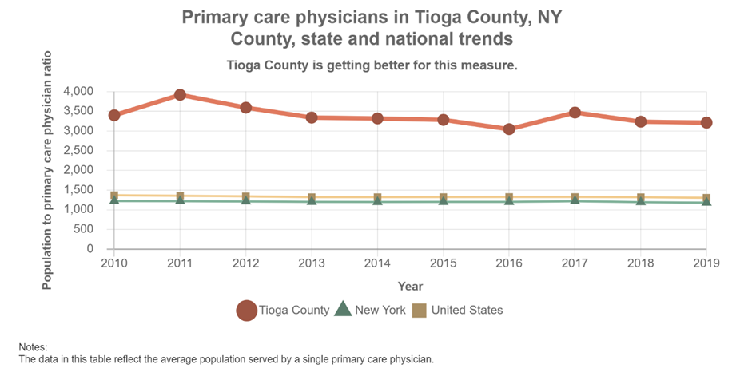
In 2018, 10.5% of Tioga County adults reported not receiving medical care because of cost (an increase from 7.3% in 2016). This was in comparison to a rate of 9.5% in the Southern Tier and 11.3% across New York State. When asked to list the top health concerns in 2019, Tioga County residents reported access to mental health providers as the second most important health problem. Currently, in and near Tioga County, the following mental health resources exist:

MENTAL HEALTH RESOURCES
Resource | Location | Phone # | Services include:
Tioga County Mental Hygiene Department | Owego; Waverly (satellite clinic) | 607-687-4000 | Open access walk-in services for mental health and alcohol and drug abuse are now available during clinic hours. No appointment required. First come, first served basis.
Abide in the Vine Counseling Center | Owego | 607-744-1100 | Faith-based family and marriage counseling service.
Center for Psychological Services | Apalachin | 607-785-4156 | Provides a vast array of services to a wide variety of populations and presenting problems.
Family & Children’s Counseling Services | Owego  Binghamton | 607-687-3540  607-729-6206 | Services include: The Family Mental Health Clinic, individual & family counseling, elderly counseling, and more.
Four Corners Assessment & Counseling, LLC | Vestal | 607-205-1394 | Provides diagnostic evaluations, psychotherapy, and counseling for those living with autism and other disabilities.
Mental Hygiene Legal Services | Elmira  Binghamton | 607-271-9262  607-240-5360 | Protects and advocates for the rights of individuals with mental illnesses, developmental disabilities, or alcoholism.
Southern Tier Counseling Solutions | Owego | 607-222-5639 | Services include grief therapy, women’s therapy, child therapy, and teen therapy.

There are no hospitals located within the borders of Tioga County. Rather, healthcare systems are present just
outside the county and include Lourdes-Ascension Health, United Health Services, Cayuga Medical Center, Guthrie, Arnot Ogden, and St. Joseph’s Hospital. “Distance to a trauma center for most residents ranges from 35 to 55 minutes. This is a concern for the towns of Richford and Berkshire, as they are over 20 miles from the nearest hospital.”

Preventive Care
Preventive care includes a healthy lifestyle, exercise, diet, and other similar efforts. Healthcare.gov defines preventive services as routine health care that includes screenings, check-ups, and patient counseling to prevent illnesses, disease, or other health problems. Recommended prevention, detection, and lifestyle activities vary by age and gender, but can include blood pressure, diabetes and cholesterol tests, cancer screenings, nutrition, depression, and drug and alcohol counseling, routine well-child visits, and vaccinations. The following list are preventive statistics from Tioga County.
• Primary care physicians in Tioga County, NY see an average of 3,237 patients per year. This represents a 6.71% decrease from the previous year (3,470 patients).
• In Tioga County, 84.5% of adults report having their blood cholesterol checked, compared with the Southern Tier rate of 79.9% and the state rate of 83.4%.
• Of Tioga County adults 65 years and older, 33% received a flu immunization within the past year, lower than the Southern Tier rate of 40.2% and the NYS rate of 44.8%. The percentage of fee-for-service Medicare enrollees that had an annual flu vaccination in Tioga County was 50%, slightly higher than the New York State rate of 49% (based on 2019 data).
• 88.9% of women aged 21-65 received a cervical cancer screening, which is higher than the NYS rate of 84.7% and the Southern Tier rate of 80.9%.

• 79.3% of women aged 50-74 years received breast cancer screenings (an increase from 71.9% in the last report), which is lower than the NYS rate of 82.1% and the Southern Tier rate of 81.5%.
• 62.7% of women aged 50-74 had a mammogram between October 2017 and December 2019, which is similar to the Southern Tier rate (62.5%), but lower than the NYS rate (71%).
• 61.4% of adults in Tioga County report visiting the dentist in the past year (similar to the previous year’s data showing 60.1%), which is lower than the Southern Tier rate of 67.9% and the state rate of 69.6%. 23.7% of Medicaid enrollees report visiting the dentist at least once for preventive care during the last year.
• Tioga County Public Health reports 782 dental screenings in 2021, compared to 631 in 2020 and 1,850 in 2019, suggesting a rebound in frequency following the COVID-19 pandemic.
• The percentage of Tioga County children aged 0-15 months in government sponsored insurance programs with the recommended number of well-child visits was 85.1% (an increase from 77.1%), compared to the Southern Tier rate of 86.5% and the state rate of 83.4%.
• Of the Tioga County children aged 3-6 years in government sponsored insurance programs, 76.3% attended the recommended number of well-child visits (an increase from 69.8%), which is lower than both the Southern Tier rate (78.2%) and the state rate (85.9%).
• 57.3% of Tioga County youth aged 12-21 in government sponsored insurance programs met the recommended number of well-child visits (a slight increase from 53.0%), which is slightly higher than the Southern Tier rate (56.8%), but lower than the state rate (68.1%).
• In Tioga County, 6.9% of adults report cardiovascular disease (heart attack, coronary heart disease, or stroke), compared to the Southern Tier rate of 7.5% and the NYS rate of 7%.
• 29.8% of adults in Tioga County have physician-diagnosed high blood pressure compared to the Southern Tier rate of 30.4% and the NYS rate of 28.9%.

Health Care Coverage
96.9% of the population in Tioga County has health coverage, with 48.8% on employee plans, 19.6% on Medicaid, 14.7% on Medicare, 12.8% on non-group plans, and 0.972% on military or VA plans. The percentage of children (less than 19 years old) with health insurance is 97.9%, which is similar to the New York State rate of 97.7%. 94.9% of adults aged 18-64 have health insurance, compared to the NYS rate of 92.5%. Between 2019 and 2020, the percent of uninsured citizens in Tioga County, NY declined by 25% from 4.16% to 3.12%.
Behavioral Health
According to the NYS Community Health Indicators Report, Tioga County had higher rates of alcohol-related motor vehicle injuries and deaths in 2017-2019 (39.8 per 100,000) than the Southern Tier Region (28.4 per 100,000) and New York State (28.9 per 100,000). This is a significant decrease from the 2014-2016 data, which reported a rate of 55.4 per 100,000 for Tioga County. The rate of cigarette smoking among adults (19.6%) and the incidence of lung and bronchus cancer in Tioga County (66.1 per 100,000) is also higher than that of New York State (13.2% and 57.6 per 100,000 respectively). 26.6% of adults in Tioga County reported binge-drinking in the last month, compared to the Southern Tier rate of 19.8% and the NYS rate of 17.5%.
Additionally, Tioga County has a similar rate of adult obesity (27.5%) compared to New York State (27.9%); when reporting on adults who are overweight or obese, the rates are similar with 61.8% of Tioga County adults and 62.5% of NYS adults falling in this category. The rate of adult obesity decreased significantly from the previous report (40.1%). 20.3% of students (with weight status information in Student Weight Status Category Reporting System) in elementary, middle, and high school in Tioga County are obese (95th percentile or higher). When considering the percent of students in elementary, middle, and high school who are overweight or obese (85th percentile or higher), that figure increases to 37%. Both of these data points have significantly worsened (from 15.9% and 31.7%, respectively).

While the Tioga County Public Health CHA survey found that 50% of Tioga County residents consider physical activity important, inactivity rates are “above 20% and trending upwards.” The percentage of Tioga County residents reporting no leisure-time physical activity was 27%. The County Health Rankings also states 49% of Tioga County residents (a significant decrease from 65%) have adequate access to locations for physical activities.
The New York State Community Health Indicator Reports indicate that among males (aged 15-44), the rate of gonorrhea is 68.8 per 100,000 in Tioga County (compared to a rate of 197.9 in the Southern Tier and 614.9 in NYS); this reflects a slight increase from 55.8 males per 100,000 in 2016. Among females (aged 15-44), the rate of gonorrhea is similar at 67 per 100,000 (with a rate of 147 in the Southern Tier and 252.5 in NYS), reflecting a decrease from 86.2 females per 100,000 in 2016. Regarding chlamydia, among males (aged 15-44), the rate is 372.5 per 100,000 in Tioga County (compared to a rate of 559.1 in the Southern Tier and 1,175.1 in NYS); this is nearly identical to the 2016 rate of 378.4 males per 100,000. Among females (aged 15-44), the rate of chlamydia is significantly higher at 774.2 per 100,000 (with a rate of 1,030.7 in the Southern Tier and 1,741.1 in NYS), a decrease from 890.8 females per 100,000 in 2016. Newly diagnosed HIV cases in Tioga County were 4.8 per 100,000 in 2020, compared to a rate per 100,000 of 4.7 in the Southern Tier and 13.1 in NYS; this reflects an improvement from 5.5 per 100,000 in 2018.
Food Environment and Nutrition
The United States Department of Agriculture defines “food security” as “access by all people at all times to enough food for an active, healthy life.” Within Tioga County, only 7.7% had low access to healthy food in 2019, a decrease from 16.2% in 2015. 13.4% of households received Food Stamp/SNAP benefits in 2019, a decrease from 14.4% of households in 2015.

The following chart depicts the recent status of food insecurity among Tioga County residents (all ages):
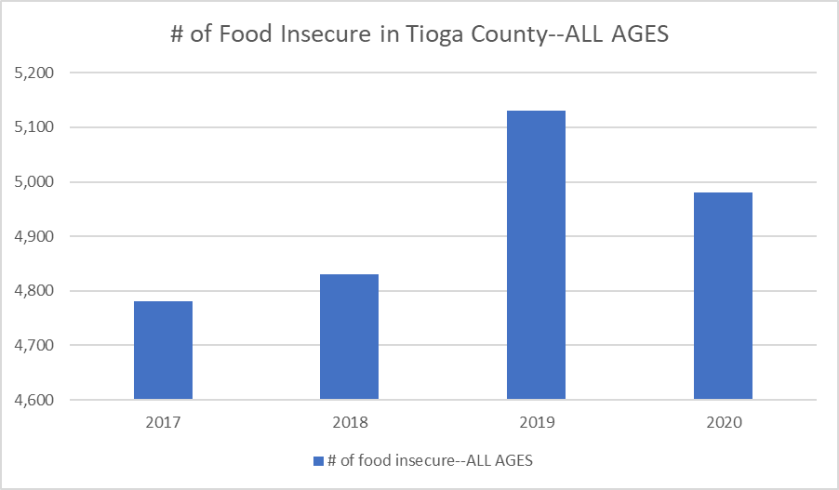
The following chart depicts the recent status of food insecurity among Tioga County residents under age 18:

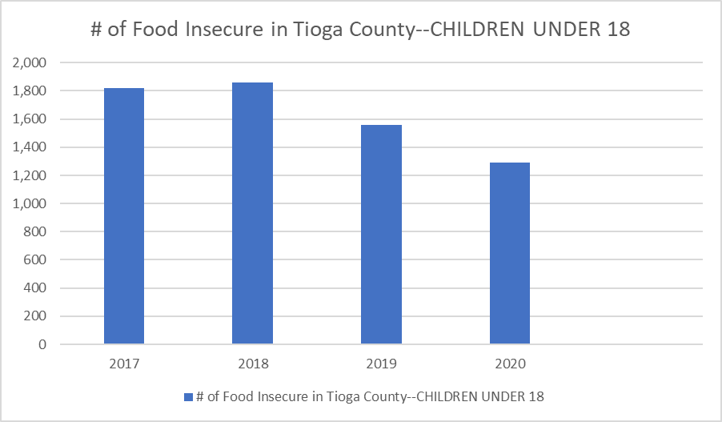
Tioga County’s food environment index is 8.7 out of 10; comparatively, Broome County’s is 7.9, Cortland County’s is 8.0, Tompkins County’s is 8.0, and Chemung County’s is 7.9. The food environment index is developed by the USDA, which assembles statistics on factors including the food choices, health and well-being, and community characteristics of residents and thus identifies food insecurity rates (with 0 being the worst and 10 being the best). Community assets actively combating food insecurity include local ministries, churches, schools, and food pantries. However, in recent years, the number of markets participating in the New York Farmers’ Market EBT/Food Stamp/SNAP Program within Tioga County has significantly declined, and an updated list of emergency food services and programs has not yet been identified.
The Tioga County Public Health Community Health Assessment states that “the main challenge nutrition educators have observed is the rural setting of the county. Accessibility of healthy food is limited. Many residents communicate their desires to make the healthier food choices, but when it comes down to the ease and accessibility, it seems that convenience is what makes the decision.” The New York State Community Health Indicators Report states that the percentage of the population with low-income and low access to a supermarket or large grocery store in Tioga County is 2.7%. Local reports suggest a concern of food deserts particularly in the remote areas of Newark Valley and Berkshire. The United States Department of Agriculture’s Economic Research Service reports that “Consumer choices about food spending and diet are likely to be influenced by the accessibility and affordability of food retailers—travel time to shopping, availability of healthy foods, and food prices. Some people and places, especially those with low income, may face greater barriers in accessing healthy and affordable food retailers, which may negatively affect diet and food security.”
Births and Prenatal Care
The birth rate in Tioga County is 9.2 per 1,000 population, which is comparable to the Southern Tier rate of 9.1 and lower than the New York State rate of 11.5. In Tioga County, 33% of live births occurred within 18 months of a previous pregnancy, compared to 33.4% in the Southern Tier and 30.4% in New York State. Additionally, the rate of children born with congenital disability (e.g. cleft lip, spina bifida, down syndrome, and cystic fibrosis) in Tioga County has increased from nearly 180 per 10,000 births in 2000 to an all-time high of 350 per 10,000 births in 2010, but sharply declined from 2010 to 2012 by about 75 births per 10,000.
Additional birth statistics for Tioga County compared to the Southern Tier region and New York State are as follows:
Indicator | Tioga County | Southern Tier | New York State
Birth rate among teens aged 15-19 | 5.6 | 4.8 | 3.1
Teen pregnancy rate per 1,000 (aged less than 18) | 2.3 | 4.8 | 4.7
Teen pregnancy rate per 1,000 (aged 18-19) | 59.9 | 24.5 | 41.1
% of births to women aged 35+ | 13.3 | 16.4 | 24.5
% of births with early (1st trimester) care | 76 | 72.3 | 76.3
% of births with late (3rd trimester) or no prenatal care | 4.5 | 4.8 | 5.4
% of births with adequate prenatal care | 83.4 | 81.2 | 75.5
% of births with low birthweight | 7 | 7.3 | 8.1
% of births with very low birthweight | 0.7 | 1.1 | 1.4
% of births to out of wedlock mothers | 45.7 | 46.4 | 37.9
Abortion rate per 1,000 live births (all ages) | 135.8 | 269.2 | 333.1

The New York State Department of Health reports the following perinatal data by zip code for Tioga County:
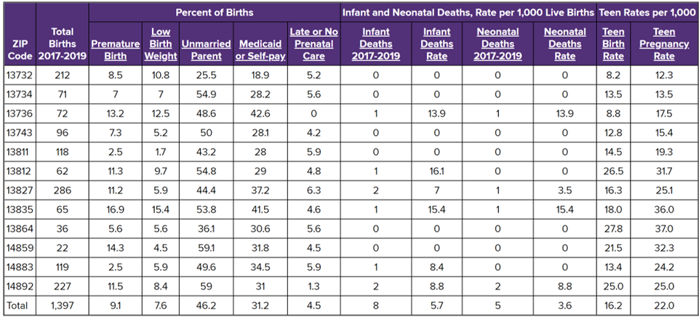

According to this data, the communities with the highest teen pregnancy rates per 1,000 are Willseyville (37.0), Richford (36.0), Lockwood (32.3), and Nichols (31.7). The highest rates of teen birth per 1,000 are Willseyville (27.8), Nichols (26.5), Waverly (25.0), and Lockwood (21.5).
Mortality and Morbidity
The mortality rate in Tioga County is 987.0 per 100,000 population (an increase from the previous report of 925.2), which is less than the Southern Tier region of 1,020.9, but significantly higher than the New York State rate of 798.8. Within Tioga County, the years of potential life lost per 100,000 is 6,504.9, which is less than that of the Southern Tier (6,821.4), but greater than that of New York State (5,781.9). According to the National Center for Health Statistics, cancer, unintentional injury, heart disease, suicide, perinatal deaths, and homicide deaths were the national leading causes of years of potential life lost before age 75. Studies show that populations at higher risk for premature death include those with obesity, those who smoke, those with a higher risk of unintentional injuries, those with heart disease risk factors, and those with increased exposure to environmental hazards. The Tioga County Public Health Community Health Assessment (CHA) reports that men die from unintentional injury three times more than women, and women die from Alzheimer’s disease twice as much as men. Unintentional injury may include poisoning, motor vehicle traffic deaths, and falls. Nationally, unintentional injuries were the leading cause of death for all groups under age 45.

Additional mortality rates (per 100,000) for Tioga County compared to the Southern Tier region and New York State are as follows:
Indicator | Tioga County | Southern Tier | New York State
All cancers | 191.9 | 206.2 | 175.5
Lung & bronchus cancer | 57.6 | 54.4 | 39.6
Female breast cancer | 21.7 | 23.1 | 25.1
Prostate cancer | 24.9 | 23.0 | 18.5
Cardiovascular disease | 286.2 | 317.3 | 278.3
Coronary heart disease | 115.3 | 151.2 | 173.4
Diabetes | 30.2 | 28.5 | 22.5
Suicide | 15.1 | 12.8 | 8.7
Unintentional injury | 48.7 | 49.5 | 37.9
Motor vehicle injury | 12.4 | 8.0 | 5.5
Alcohol related motor vehicle injuries & deaths | 39.8 | 28.4 | 28.9
*COVID-related deaths listed separately within this section.
Drug-related Overdoses and Deaths
CASA-Trinity Inc., a local Council on Alcohol and Substance abuse that provides high-quality prevention, treatment, and recovery services for the individuals, families, and communities in the Southern Tier, shared the following data regarding drug-related overdoses and deaths for 2021 and 2022. Data was provided by the Tioga County Sheriff’s Department.
2021: All overdoses, Tioga County
Description | Jan | Feb | Mar | Apr | May | Jun | Jul | Aug | Sep | Oct | Nov | Dec | YTD Totals
Total # of overdoses | 6 | 10 | 9 | 4 | 7 | 8 | 10 | 13 | 6 | 9 | 9 |  | 91
*Opioid involved overdoses | 2 | 7 | 4 | 3 | 2 | 4 | 5 | 9 | 4 | 4 | 7 |  | 51
*Accidental/non-opioid  overdoses | 4 | 3 | 5 | 1 | 5 | 4 | 5 | 4 | 2 | 5 | 2 |  | 40
Narcan administered (# of persons received) | 1 | 1 | 2 | 0 | 1 | 2 | 1 | 5 | 2 | 2 | 4 |  | 21
Fatalities | 0 | 2 | 1 | 0 | 0 | 1 | 0 | 0 | 0 | 0 | 0 |  | 4

*December 2021 data not reported

*December 2021 data not reported

2022: All overdoses, Tioga County (through August 2022)
Description | Jan | Feb | Mar | Apr | May | Jun | Jul | Aug | Sep | Oct | Nov | Dec | YTD Totals
Total # of overdoses | 6 | 2 | 6 | 8 | 3 | 7 | 6 | 10 |  |  |  |  | 48
*Opioid involved overdoses | 2 | 2 | 1 | 4 | 3 | 4 | 3 | 6 |  |  |  |  | 25
*Accidental/ non-opioid overdoses | 4 | 0 | 5 | 4 | 0 | 3 | 3 | 4 |  |  |  |  | 23
Narcan administered (# of persons received) | 2 | 0 | 1 | 2 | 0 | 1 | 0 | 2 |  |  |  |  | 8
Fatalities | 0 | 1 | 0 | 1 | 0 | 0 | 0 | 0 |  |  |  |  | 2

*Data reported through August 2022

*Data reported through August 2022
COVID-19
The COVID-19 pandemic began on March 14, 2020. Through December 2021, there were 7,172 confirmed cases in Tioga County. The Tioga County Public Health Department tracked 19,073 individuals and issued quarantine/isolation orders to 17,909 people. On January 13, 2021, the first COVID-19 vaccination clinic was held at UHS in Owego. 100 doses of the Moderna vaccine were administered to essential workers at that event. Throughout 2021, the Tioga County Public Health Department held a total of 36 clinics and administered 4,264 vaccinations. The largest clinic vaccinated about 460 individuals. Ten homebound individuals were vaccinated with the single-dose Johnson & Johnson vaccine. Data from USA Facts indicates that there have been 88 deaths in Tioga County relating to the COVID-19 pandemic.

The following data was reported for Tioga County via the New York Times:
As of October 2022, the following COVID-19 vaccination statistics apply to Tioga County:
Cumulative # of COVID-19 vaccinations | Number | % in Population
People vaccinated with at least one dose | 34,480 | 70.30%
People fully vaccinated | 30,089 | 61.35%
*“Fully vaccinated” indicates a complete first series of the COVID vaccine.

CHAPTER 10: CHILD CARE
According to an article published by the Brookings Institute, “community-based early care and education, delivered at scale, can provide lasting impacts, and may serve as a catalyst for children’s success later in life—particularly for those from less resourced environments. Early childhood programs that are sustained and high quality can have long-lasting impacts on children, preparing them for formal schooling and beyond with the added factor that early education paves the way for parents to be in the workforce.”
We need high quality early childhood care to set children on paths that will enable them to thrive. High-quality childcare helps children be more successful in school and has shown improved health and increased earning outcomes over children's lifetimes.
The availability of high-quality childcare impacts families, children, and the economy. Closures can have far reaching ramifications throughout our communities. Availability was tested immensely during the height of the Pandemic throughout the United States, New York State and in the Southern Tier. According to The Children’s Agenda – Rebuilding Our Future: Child Care Closures in New York During the Pandemic, Tioga County lost 275 licensed/registered childcare slots between January 2020 and July 2022 or 35% of its total Child Care Capacity. Broome and Chemung Counties fared much better. Broome only saw a net total loss of 4 slots and Chemung lost 171 slots or 7% of its overall capacity. In total, NYS saw 3,524 childcare programs close between 2020 and 2022.
The childcare option that was most affected was in-home care (known as family or group family child care). Rural, upstate communities’ lost capacity at a higher rate than other regions.
Available Child Care
TABLE ___ reports the number and types of regulated childcare programs by school districts in Tioga County. Of the total number of licensed/registered day care options in Tioga County (20), eight are located in the Owego-Apalachin school district, two in Candor and Newark Valley, three in the Waverly School District, and one is in Spencer-Van Etten School District. No childcare programs are located in the Tioga Central School District. The most common type of childcare program in Tioga County is family day care, of which there are eight total; followed by day care centers and group family day care (six each). Many day care options are located in the Owego-Apalachin school district.

TABLE 10.1 - REGULATED CHILD CARE PROGRAMS BY LOCATION IN TIOGA COUNTY, 2022
Municipality | Day Care Center | Family Day Care | Group Family Day Care | School Age Day Care | Small Day Care Center | TOTAL
Candor | 0 | 2 | 0 | 0 | 0 | 2
Nichols | 1 | 0 | 1 | 0 | 0 | 2
Newark Valley | 1 | 0 | 1 | 0 | 0 | 2
Owego/Apalachin | 3 | 3 | 2 | 0 | 0 | 8
Spencer | 0 | 1 | 0 | 0 | 0 | 1
Tioga | 0 | 0 | 0 | 0 | 0 | 0
Endicott (TC) | 0 | 1 | 0 | 0 | 0 | 1
Waverly | 1 | 0 | 2 | 0 | 0 | 3
Willseyville | 0 | 1 | 0 | 0 | 0 | 1
ALL | 6 | 8 | 6 | 0 | 0 | 20
Source: New York State Division of Child Care Services, Day Care Facility Search. Accessed October 2022.
Day Care Centers – provide care for more than six children at a time, not in a personal residence
Small Day Care Centers – provide Care for up to six children, not in a personal residence.
Family Day Care Homes – provide care for three to six children at a time in a residence; may add one or two school-age children. The maximum number of children will depend on whether there are and how many infants are in care.
Group Family Day Care Homes – provide care for seven to twelve children at a time in a residence; may add one or two school-age children. The maximum number of children depend on whether there are and how many infants are in care. A provider must use an assistant when more than six children are present.
School-Age Child Care Programs – provide care for more than six children from kindergarten through age 12. Care for children during non-school hours; also, may provide care during school vacation periods and holidays.

What is Legally Exempt Child Care?
Legally Exempt child care is a different option of child care. It is a great option for families with unique schedules or have access to legally exempt providers. This program allows parents to hire close, dependable, reliable friends, family members, or neighbors as their child’s care provider. These individuals are called Legally Exempt Child Care. These types of providers can receive subsidy payments, or daycare assistance if the family qualifies, from the county they perform their services in.
Legally exempt care has dropped significantly since the federal Child Care Development Block Grant (CCDBG) brought several changes to the New York State subsidy system, which included legally exempt providers. As of September 2019, new legally exempt enrollment requirements were put into place. Including a comprehensive background check, which includes the NYS Sex Offender Registry, Staff Exclusion List, checking for abuse/neglect against individuals with special needs, the Statewide Central Register of Child Abuse & Maltreatment (SCR), and fingerprints for criminal conviction history in any state the provider has lived. Relative providers, including grandparents, siblings, aunts, uncles, are exempt from the comprehensive background checks.

Legally Exempt Providers by Type (2021)
COUNTY | FAMILY CHILD CARE | IN HOME | GROUP
BROOME | 29 | 38 | 1
CHENANGO | 6 | 11 | 0
TIOGA | 16 | 21 | 1

Effects of COVID on Child Care Closures
One must consider these data sets to accurately document the extent and impact of child care closures during the pandemic:
- Declines in families using child care and child care assistance programs
- Number of licensed/registered child care programs in operation
- Number of childcare slots
- Capacity of communities to adequately address childcare challenges
New York State compared data published on July 5, 2022, against a data set downloaded on January 23, 2020. This information indicated which programs were active prior to the COVID-19 pandemic that have closed and what programs have opened, providing a snapshot of the overall capacity across New York State.
The number of New York families accessing paid child care saw a steep decline during the pandemic. While all states saw a decline, New York’s was significantly larger than most other parts of the country. Prior to the pandemic, New York had the 16th highest use of paid care nationally. In 2020 the state had fallen to 35th.
The decline in usage of child care was accompanied by a significant decline in participation in a state’s child care assistance program. The number of children receiving child care subsidies in Tioga declined 36%.
DECLINE in CHILD CARE ASSISTANCE RECIPIENTS by COUNTY
DISTRICT NAME | 2019 | 2021 | 2019 to 2021%  CHANGE
BROOME | 800 | 535 | -33%
CHEMUNG | 660 | 391 | -41%
CORTLAND | 109 | 58 | -47%
SCHUYLER | 73 | 48 | -34%
TOMPKINS | 238 | 108 | -55%
TIOGA | 220 | 141 | -36%
NEW YORK STATE | 111,335 | 70,028 | -37%
DECLINE in CHILD CARE CAPACITY by COUNTY for ALL AGES and ALL TYPES of PROGRAMS
COUNTY | 2020 TOTAL  Available Slots | 2022 TOTAL  Available Slots | PANDEMIC  TOTAL CHANGE | PANDEMIC TOTAL  % CHANGE
BROOME | 4,388 | 4,392 | 4 | 0%
CHEMUNG | 2,350 | 2,179 | -171 | -7%
CORTLAND | 1,488 | 1,277 | -211 | -14%
SCHUYLER | 467 | 423 | -44 | -9%
TOMPKINS | 3,012 | 3,037 | 25 | 1%
TIOGA | 776 | 501 | -275 | -35%
NEW YORK STATE | 654,122 | 643,562 | -10,560 | -2%
Tioga County had the highest decline percentage in child care capacity in the state.
The Southern Tier Regional Economic Development Council which serves, Broome, Chenango, Chemung, Delaware, Schuyler, Steuben, Tioga, and Tompkins Counties, considers the Southern Tier Region a child care desert, which is defined by the Center for American Progress as any census tract with more than 50 children under age 5 that contains either no child care providers or so few options that there are more than three times as many children as licensed child care slots. The Southern Tier region consistently has a need for high quality infant care and options for school aged children. Major industries, such as Tioga Downs, Health Care (Guthrie, UHS, Ascension), to name a few, create a need for non-traditional hours of care including weekends, evenings, flexible hours, and rotating schedules. The region also has a significant need for sustainable home-based Family or Group Family child care in rural areas. Care for children with special behavioral needs, such as autism, is also a priority for the region. In addition, full-time care is a priority for the region since many of the licensed Centers are Head Start programs that do not offer full-day and full-year child care.
New York State received $163.6 million in dedicated child care funding from the CARES Act. The state struggled to use this funding effectively to support the child care sector during the height of the pandemic. New York state’s CARES Act child care provider relief efforts were reimbursement-based. This meant that providers, who were experiencing significant drops in enrollment, had to have enough revenue to cover costs while waiting to be reimbursed.
Nine months after receiving the federal funds, the state had only spent 9% of the total allocation. The $136.6 million CARES Act funding was eventually spent out, although a large portion was dedicated to essential scholarships and other purposes instead of provider relief efforts.
Stabilization Grants
Learning from previous mistakes, New York state rolled out a broader-based relief program branded as “stabilization” grants. License, registered, and certain legally exempt child care providers were able to access grants through a more streamlined, online application process. Grant amounts were determined by a provider’s locality, location, and licensed capacity.
These grants were weighted in favor of home-based providers and family child care and group family child care providers received more of the grant funding than center-based programs. This targeted relief addressed the unique challenges faced by in-home providers. In the end, $900 million was committed to 14,885 providers, which is almost 84% of potential grant recipients.
Due to the success of the initial stabilization grant program, Governor Hochul announced in July 2022, the appropriation of an additional $343 million in remaining federal funding to launch another similar initiative. OCFS has awarded $208 million to 12,578 child care providers through the Stabilization 2.0 for Workforce Supports grant. The second child care stabilization grant was released on July 5, 2022. Applications were closed for the Child Care Stabilization 2.0 for Workforce Supports on December 14, 2022.
The New York State Office of Children & Family Services is also amid a $100 million dollar initiative to reduce the prevalence of child care deserts. The first round of awards announced in July of 2022, focused on increasing the number and capacity of providers in underserved census tracts across the state.
Child Care Assistance Program Market Rates
Market-related payment rates are established in five groupings of counties. The rates established for each group apply to all counties in the designated group. Tioga County falls in Group 3 Counties which includes: Allegany, Broome, Cattaraugus, Chautauqua, Chemung, Chenango, Clinton, Cortland, Delaware, Essex, Franklin, Fulton, Genesee, Greene, Hamilton, Herkimer, Jefferson, Lewis, Livingston, Madison, Montgomery, Niagara, Oneida, Orleans, Oswego, Otsego, Schoharie, Schuyler, Seneca, St. Lawrence, Steuben, Sullivan, Tioga, Washington, Wayne, Wyoming, Yates.
Federal and New York State law require the state to establish payment rates for child care assistance that are sufficient to ensure equal access to child care services for eligible children, as compared to children not eligible for assistance [42 USC §9858c(c)(4)(A); New York State Social Services Law (SSL) §410-x(4)]. Federal regulation requires that payment rates be based on the results of the most recent market rate survey or an approved alternative methodology [45 CFR §98.45(f)(2)(i)].
State law requires the New York State Office of Children and Family Services (OCFS) to establish market-related payment rates for child care services (SSL §410-x(4)). The market rates must consider the variations in costs of providing child care in different settings and to children of different age groups as well as the additional cost of providing child care to children with special needs.

Below are the market rates for Group 3 Counties as of June 2022.

TABLE 10.2 - TIOGA COUNTY CHILD CARE MARKET RATES, June 2022
DAY CARE CENTER
Weekly | Under 1.5 YR | 1.5-2 YR | 3-5 YR | 6-12 YR
 | $295 | $275 | $253 | $245
Daily | $64 | $59 | $55 | $55
Part-Day | $43 | $39 | $37 | $37
FAMILY DAY CARE HOME AND GROUP FAMILY DAY CARE HOME
Weekly | Under 2 YR | 2 YR | 3-5 YR | 6-12 YR
 | $266 | $252 | $250 | $225
Daily | $55 | $53 | $50 | $50
Part-Day | $37 | $35 | $33 | $33
Hourly | - | - | - | -
SCHOOL-AGE CHILD CARE
Weekly | Under 1.5 YR | 1.5-2 YR | 3-5 YR | 6-12 YR
 | $0 | $0 | $253 | $245
Daily | $0 | $0 | $55 | $55
Part-Day | $0 | $0 | $37 | $37
Hourly | - | - | - | -
LEGALLY EXEMPT GROUP CHILD CARE STANDARD RATE
Weekly | Under 1.5 YR | 1.5-2 YR | 3-5 YR | 6-12 YR
 | $0 | $0 | $190 | $184
Daily | $0 | $0 | $41 | $41
Part-Day | $0 | $0 | $28 | $28
Hourly | - | - | - | -
INFORMAL CHILD CARE STANDARD RATE
Weekly | Under 2 YR | 2 YR | 3-5 YR | 6-12 YR
 | $173 | $164 | $163 | $146
Daily | $36 | $34 | $33 | $33
Part-Day | $24 | $23 | $21 | $21
Hourly | - | - | - | -
INFORMAL CHILD CARE ENHANCED RATE
Weekly | Under 2 YR | 2 YR | 3-5 YR | 6-12 YR
 | $186 | $176 | $175 | $158
Daily | $39 | $37 | $35 | $35
Part-Day | $26 | $25 | $23 | $23
Hourly | - | - | - | -
New York State Office of Children and Family Services, Local Commissioners Memorandum, June 3, 2022

Child Care Deserts
The Center for American Progress released a report showing areas of the United States where there is a lack of child care. For the report, the Center for American Progress collected and analyzed data on the location and capacity of registered/licensed child care in every state, comparing it to the estimates in population, family income and labor force participation for every U.S. census track. The analysis shows 51% of Americans live in a child care desert. Most of Broome, Chenango, and Tioga Counties are identified as being a child care desert. The report shows that rural areas have a higher concentration of child care deserts, which is consistent with our area.
Current Initiatives
Gov. Kathy Hochul recently announced the largest investment in child care subsidies in New York State history will be distributed – $2 billion to increase the number of families receiving child care financial assistance and the amount child care providers are paid for their essential services.
As part of the governor's commitment of $7 billion to child care over the next four years, these investments are designed to provide families with much-needed support, while also furthering New York's economic recovery. With the income threshold for child care subsidies increasing, an unprecedented number of young children in New York will now be eligible. The funding, managed by the New York State Office of Children and Family Services (OCFS), will expand the initial eligibility levels for families in August 2022 to up to 300% of the federal poverty level ($83,250 for a family of four), up from 200%, extending eligibility to hundreds of thousands of young children in New York.
TABLE 10.3- NEW YORK CHILD CARE BLOCK GRANT SUBSIDY PROGRAM ALLOCATIONS, 2022-2023
Tioga County |  | New York State
Apr. 2022 - Sept. 2022 | $651,159 | $447,313,487
Oct. 2022 - Mar. 2023 | $651,159 | $447,313,487
Final SFY 2022 – 2023 Allocation | $1,302,318 | $894,627,001
New York State Office of Children and Family Services, Local Commissioners Memorandum, April 2022

In a report from the Supporting Families, Employers, and New York’s Future: An Action Plan for a Strong and Equitable Child Care System Final Report of the Child Care Availability Task Force, the following conclusion was highlighted.
“Decades of treating, and funding child care as a private service rather than a public good in New York — and around the nation — has left the system teetering on collapse, propped up in large part by underpaying the workforce, one that is overwhelmingly populated by women, largely women of color, who are paid wages that leave the majority in near poverty. The extraordinary stressors of the pandemic have strained New York’s fragile system to its breaking point.”
CHAPTER 11: RECREATION & TOURISM
Tioga County recreational and tourism activities include agriculture, arts, dining, craft beverages, golf, history, lodging, outdoor recreation, shopping, and wedding events. Located near the Finger Lakes, Tioga County offers convenient, affordable lodging including historic inns and trusted chain hotels. It is home to the nation’s first certified organic dairy farm, as well as pumpkin and blueberry farms, homegrown maple syrup, honey, and lavender products, and vibrant greenhouses and farmers markets. Tioga County is “the gateway to the Finger Lakes” and has access to many beer and wine trails. It is home to a brewery, vineyard, distillery, and winery of its own. There are 19 well-known parks within Tioga County, which feature state park hiking trails, waterfalls, river walks, birdwatching sites, a nature preserve, and a wetland preserve. Historic sites within the county include farmstead museums, historical societies and exhibits, Civil War cannons, notable grave sites and monuments, historical architecture and houses, and the first official freight train of the Southern Central Railroad. Additional attractions include ten golf courses, numerous quaint village and town shops, and the Tioga Downs Casino and Resort which hosts gaming, harness racing, a spa, concerts, and banquet events.
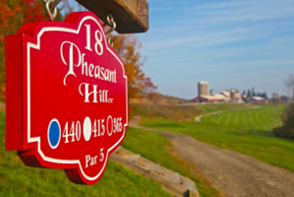
Data compiled by the National Travel and Tourism Office show that New York was the second most visited state in the nation in 2021 with 2,099,000 visitors. Tioga County Tourism adopted a strategic plan in 2019 to guide its operations, major actions of which include creating and implementing a digital marketing campaign; improving product development and promotions; optimizing partnerships; and exploring and utilizing creative people resources.
Tioga County Tourism seeks to maintain and strengthen Tioga County’s position as a tourism destination and intends to:
- Increase visitors’ length of stay and spending by assisting
tourism assets such as historic properties, lodging,
greenspaces, and walkable downtown spaces, as well as
increasing recreational, cultural, and entertainment opportunities, including recreational opportunities on the Susquehanna River
- Increase continual contact between the Tioga County Legislature and state representatives to allocate funds in State Parks budget to develop Two Rivers State Park in Waverly.
- Capitalize on the increased visitor traffic at Tioga Downs Casino through on-site promotion
- Support new tourism product development such as an outlet mall adjacent to Tioga Downs and an outdoor/indoor recreational facility.
- Market to traffic on I-86 through the use of the NYS DOT LOGO and TOD highway signs and the
creation of a visitor’s center; and
- Promote and support Agricultural Tourism Initiatives that highlight farm tours, locally grown and farm products.

The Tioga County Economic Development & Planning 2021 Annual Report shows that Tioga County Tourism (TCT) continued to operate on an adjusted marketing plan due to COVID-19, having devoted more funds and focus to product development. 260 In addition, TCT changed in response to how people search and find tourism information and implemented a free application for all iPhone and android devices called Experience Tioga NY. This app serves as a simple and efficient way for users, including partner businesses, to search for and find activities throughout the county. TCT is also working to support the creative community through the downtown revitalization wayfinding sign project, providing online services for technical support for small businesses, and is working to provide grant funds to assist with promotional efforts for Tioga County events. TCT plans to focus on outdoor recreation including a "regional paddle trail, an interactive trail system, digital and hard copy mapping Trails of Tioga".

CHAPTER 12: PUBLIC SAFETY
Overall, crime in Tioga County has seen a gradual decrease in the last few years. This could be contributed to the decline in overall population in the county. However, there seems to be a consistent trend of recidivism for individuals on probation. This could be due to a multitude of factors from environment to lack of support systems.
Arrests
In 2021, 494 total arrests were made in Tioga County. The arrests per year decreased from 707 in 2018. However, the was a slight increase from 2020 to 2021 of 94 arrests. Of the total arrests made, 34% were felony arrests and 66% were misdemeanor arrests. Thirty percent of all arrests were drug- and alcohol-related; nine percent were violent; fifteen percent were property; and forty-seven percent were “other.” The age of the individuals arrested is spread out over different age ranges. Most arrests were made among those between 25-44 years old; aged 30 to 34 years (19%), followed by those aged 25 to 29 years (18%), 35 to 39 years (17%), and 40 to 44 years (12%). Since 2018, there has been an increase in the percentage of individuals arrested in the ranges of 35 to 39 years and 40 to 44 years. In trend with previous years, most females were arrested on DWI and drug charges, while male arrests continue to dominate the violent felony charges categories. Since 2018, the number of arrests in all categories has declined, except in violent crime arrests, which has increased to 44 arrests from 34 in 2018.
TABLE 12.1 – TIOGA COUNTY ADULT ARRESTS BY
SEX, 2021 (Source – DCJS, Criminal History System)
 | # Total Arrests | % Male Arrests | %  Female Arrests
Total | 494 | 79% | 21%
Felony Total | 168 | 81% | 19%
Drug | 27 | 67% | 33%
Violent | 44 | 91% | 9%
DWI | 11 | 73% | 21%
Other | 86 | 81% | 19%
Misdemeanor Total | 326 | 78% | 22%
Drug | 64 | 72% | 28%
DWI | 44 | 80% | 20%
Property | 73 | 84% | 16%
Other | 145 | 77% | 23%
Tioga County Arrests per Year
800

700

600

500

400

300

200

100

0
2018
2019
2020
2021
Total Arrests
Total Felony Arrests
Total Misdemeanor Arrests

Crime
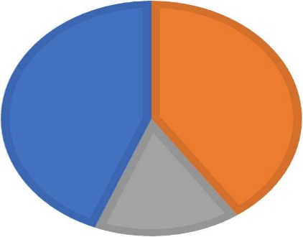
Over the last five years in Tioga County, there have been three hate crimes that occurred: one in 2017, one in 2019, and the other in 2020. From 2018 to 2021, the incidence of property crime (e.g. burglary, larceny, motor vehicle theft) in the county far exceeded that of violent crime (e.g. murder, rape, robbery, aggravated assault), and the total property crime decreased over time (405 property crimes in 2017 compared to 363 in 2021). There were 1,883 property crimes from 2017 to 2021 compared to 265 violent crimes. Violent crime rates have increased from 48 in 2017 to 57 in 2021; most violent crimes that have been reported between 2017 to 2021 were rape (45%) and aggravated assault (47%), whereas the majority of property crimes during this time were larceny (74%).
VIOLENT CRIME BY TYPE, 2021
Rape
Robbery
Agg. Assault
44%
40%
16%

Overall, the index crime rate in Tioga County is 859.8 per 100,000, which is significantly lower than that of New York State (1,731.3) and Non-New York City (1,381.1). Taken together with local data, this suggests that Tioga County is a safe place to live.
Domestic Abuse
TABLE 12.2 - DOMESTIC VIOLENCE VICTIMS REPORTED IN TIOGA COUNTY, 2021
 | Intimate Partner |  | Other Family Victim | TOTAL
 | Female Victim | Male Victim
Agg. Assault | 6 | 0 | 3 | 9
Simple Assault | 34 | 9 | 25 | 68
Sex Offense | 3 | 0 | 6 | 9
Violate Protection Order | 7 | 0 | 1 | 8
TOTAL | 50 | 9 | 35 | 94
There is currently one domestic violence and abuse shelter and program in Tioga County, called A New Hope Center, which is in the Village of Owego. This agency provides services to individuals affected by domestic violence, sexual assault, and crime including counseling and advocacy, residential services, supervised visitation programs, domestic violence classes for men, and a survivors’ support group. TABLE 11.2 depicts domestic violence data in Tioga County from 2021, where “intimate partner” includes spouse, ex-spouse, and those in an intimate relationship; and “other family” includes sibling, child, grandparent, grandchild, in- law, step-parent, step-sibling, and other blood and in-law relationships. Reports of domestic violence are down from 2018 (107 reports), but have not decreased more than one reported case since 2019 (95 reports). It is important to highlight that these numbers reflect those cases that have been reported. There have been many cases where an official report was not filed.
Recidivism
A consistent pattern in Tioga County is the chance for recidivism of those individuals on probation within the first five years. Since 2011, there is an average increase of at least 5% with each year that a previous offender will be arrested for another offense. From 2011-2017 the amount of those individuals that have been arrested while on probation is an average of 40-50%. Within the same population, 30-35% of individuals are convicted of another offense within the five years following the original conviction, with 15-20% resulting in incarceration. The county has a limited amount of support services for those individuals that are on probation to reenter the community.
Protective and Preventative Services
In 2020, Tioga County Child Protective Services (CPS) received 1,208 reports. Of the CPS reports, 860 were tracked to the investigative units and 348 were tracked to the Family Assessment Response (FAR) Unit. Of the 1208 cases tracked as investigations, 246 were consolidated with subsequent reports, 187 were secondary reports, and 87 were duplicate reports. Tioga County was responsible for determining the remaining 440 reports. 17% of the Central Registry reports received contained allegations involving drug use, which is slight decrease from 2019. Of the total of 498 (included carry over from 2020) 307 were determined to be unfounded and 156 were indicted and closed, while 35 were kept open for ongoing services. Additionally, Adult Protective/Adolescent Services reported 263 adult services referrals in 2020. The department reports 58 adult protective investigations were conducted.
The Tioga County Department of Social Services In-House Preventive Services were provided to 58 families with 153 children. Eleven of the 58 families were discharged from Preventive Services. An additional preventive service program in the county is the Tioga County Youth Bureau, which addresses the priorities of preventing child abuse and neglect and provides programs for youth during non-school hours. In 2020, the Tioga County Youth Bureau and its Board provided funding to eleven programs that served a total of 1,000 youth.

Foster Care and Adoption
Tioga County continues to rank above the State and national average regarding safety and stability foster care indicators. The federal guidelines define stability as having two or fewer placements for children that have been in foster care less than one year. Of the 15 children discharged from foster care, seven were reunited with a parent, four were discharged to a relative, four were discharged to their own care; and two of the 10 children were discharged within one year of their placement date.
Six new foster homes were opened. Of those six homes, four were emergency certified to care for relative children. This eliminates the need for children to be placed with strangers and assists with allowing for continued stability through their family connections.

CHAPTER 13: EMERGENCY PREPAREDNESS
Tioga County continues to make efforts to build the foundation to be prepared for emergencies and to meet ongoing needs. Most emergency services in the county are provided by volunteers. The Office of Emergency Management continues to play an integral role in preparation and execution of emergency situations in response to COVID pandemic. In 2020, the office acted a liaison with New York State to distribute necessary supplies for the health and safety of the community. Currently, the County is seeing a shift in the ability to meet the need of emergency services and will continue to work on implementing necessary changes best serve the community.
Emergency Services
The Tioga County Office of Emergency Services coordinates the County’s efforts to prepare for and respond to emergency situations. “In an emergency situation, the Office of Emergency Services works with County departments and external agencies to respond to the needs of citizens by helping to protect lives and property, assist those injured or whose normal lives have been disrupted by events, and to provide for the rapid restoration of normal services.” Additionally, the Office of Emergency Services provides support and assistance to the volunteer fire departments and emergency squad/first responder units in Tioga County. The County is served by 15 volunteer fire departments and 15 emergency squads/first responder units.
The County recently conducted a study to evaluate options for the future regarding their EMS system as agencies are struggling to meet the needs of the community. Per the Tioga County EMS study, New York State has seen a decline of 27% in the number of Emergency Medical Technicians from 2017 to 2022. In Tioga County that decline was much larger with a decrease of 42%. Currently nine ambulance services operate independently from one another but are available to provide aid. According to the recent study, the demand for EMS services will continue to increase 5 to 10 percent per year. This increase can be correlated to the aging population of Tioga County. Suggested strategies to assist with this issue are the addition of a full-time EMS Coordinator, encouraging the use of the same software, establishing performance goals, and the development of model agreements for EMS service for Towns.
The Emergency 9-1-1 Communications Center is the sole Public Safety Answering Point for the county from which every emergency response is communicated. Its public safety dispatchers maintain operations throughout the year and include performing emergency communications for all law enforcement operating within the county. This includes communication between dispatchers and Sheriff patrols, State Police, Environmental Conservation Police, Owego Police, Waverly Police, the emergency squads, first responders, and fire departments, the County Fire Investigation Team, County Hazmat Team, County Search and Rescue, and the Medi-Vac Helicopter. The Center also collaborates with the Tioga County Public Health Department, Mental Health Department, Social Services, Municipal Highway Departments, and Animal Control by providing “after-hour” referrals.
Natural, Technological and Man-Made Hazards
In 2012, “The Tioga County Hazard Mitigation Planning Committee evaluated and ranked natural hazards of concern for Tioga County using methodologies promoted by FEMA’s hazard mitigation planning guidance and generated by FEMA’s HAZUS-MH risk assessment tool. This risk assessment identified approximately Twenty-three natural hazards that can potentially affect Tioga County and determined that ten natural hazards are considered significant risk to Tioga County, five of which are defined as Hazards of Concern, or those most likely to seriously impact the county.”
Table 13.1 below provides an overview of the types of hazards of most concern and frequency of these hazards for Tioga County.

TABLE 13.1 – CONCERNING NATURAL HAZARDS IN TIOGA COUNTY
Rank | Top Natural Hazards of Concern | Other Natural Hazards of Significant Risk
1 | (Riverine, Flash and Dam) Flooding | Ice Storm
2 | Severe (Windstorm, Thunderstorm, Hailstorm,  and Lightning) Storm | Ice Jam
3 | Severe Winter (Heavy Snow, Blizzard, Freezing  Rain, Sleet, and Nor’easter) Storm | Windstorm
4 | Earthquake | Tornado
5 | Drought | Hurricane and Tropical Storm
HAZARDS POSING GREATEST THREAT TO LIFE |  | HAZARDS OCCURING WITH LITTLE/NO  WARNING
Transportation Accident |  | Severe Storm
Security, Improvised Explosive or Active Shooter Event |  | Landslide
Terrorist Act |  | Dam Failure
Epidemic/Pandemic |  | Utility Failure
Hazardous Materials (Fixed Site) |  | Flood
 |  | Tornado
HAZARDS OCCURING MOST OFTEN IN TIOGA COUNTY |  | Fire
 |  | Earthquake
Severe Storm |  | Security, Improvised Explosive or Active  Shooter Event
Severe Winter Storm |  | Terrorist Act
Flood |  | Critical Infrastructure or Key Resource  Failure
Transportation Accident |  | Transportation Accident
Windstorm |  | Wildfire
Fire |  | Hazardous Materials (in Transit and Fixed  Site)
Hazardous Materials (in Transit) |  | Water Supply Contamination
Oil Spill |  | Transportation Accident
Extreme Temperatures |  | Oil Spill
 |  | Structural Collapse
Source: 2013 Tioga County Comprehensive Emergency Management Plan

The 2013 Tioga County Comprehensive Emergency Management Plan addressed the following as strategies to mitigate hazards in Tioga County: emergency services, public education and awareness, structural design and development standards, property protection, retrofitting and removal, structural protection and natural resource protection. The following special populations were identified as vulnerable populations, those who may have heightened risk or response needs associated with identified hazards: people 65 years and older; people under the age of 20, people with disabilities, people who are institutionalized; people who are below the poverty level; and people who speak a language other than English at home.
The 2013 Tioga County Comprehensive Emergency Management Plan addressed the following as strategies to mitigate hazards in Tioga County: emergency services, public education and awareness, structural design and development standards, property protection, retrofitting and removal, structural protection and natural resource protection. Additionally, the following special populations were identified as vulnerable populations, those who may have heightened risk or response needs associated with identified hazards: people 65 years and older; people under the age of 20, people with disabilities, people who are institutionalized; people who are below the poverty level; and people who speak a language other than English at home.
Emergency Preparedness
While an update to the 2013 County Emergency Management Plan has not been released, officials recognize a group of key agents who help assess disasters in Tioga County. Disaster services in Tioga County are coordinated by a multi-agency committee consisting of county, regional, and area human service providers that regularly serve the community.
Unified management of human services during a disaster in the county is accomplished by coordinating the efforts of multiple county and regional human service agencies under the provisions of the Tioga County Comprehensive Emergency Management Plan and by mobilizing representatives of these services at the Tioga County Emergency Operations Center and the Tioga County Health and Human Services Building. Additional support is available through the county Disaster Human Services Committee. The committee is responsible for preparedness and planning related to disaster services, coordinating, and managing services during disasters, and providing leadership, staffing, resources, and support needed to deliver disaster aid. In 2018, Tioga County Emergency Services organized a committee referred to as the Local Emergency Planning Committee (LEPC) to discuss potential hazards in Tioga County, as well as mitigation strategies and response to hazards.
Disaster, Assessment, and Recovery
Recently, as part of ongoing emergency preparedness efforts, the Tioga County Community Organizations Active in Disaster (C.O.A.D.) is being revamped to reflect the current state of the organizations in the county and surrounding areas. The purpose of a C.O.A.D. is for community-based organizations to plan and execute a collaborative effort to meet non-emergency needs during/following a disaster. This can include donation sites, meal preparation, supply distribution, etc. Emergency plans cite that in the event of an emergency, authorized officials and media utilize the Emergency Alert System. When the announcement involves greater complexity and is less urgent, news releases, public announcements, photos, and videos can be alternative effective means of distributing emergency information. Officials are also familiar with utilizing alternative communication methods as applicable.
CHAPTER 5: KEY FINDINGS
Given the data presented in this assessment, the following are considered key findings.
DEMOGRAPHICS
  - Expected population loss of over 10,000 residents between 2010 and 2040, while 65+ age cohort is expected to grow by over 20%.
  - Dramatic growth in the number and proportion of older persons in the population, which most notably affects the housing market and the workforce.
  - 65.7% of the population is considered to be dependent - 28.8% are older adults and 36.9% are children.
  - Higher rate of people with disabilities when compared to NYS, but like surrounding counties.
  - NYS has the 5th largest veteran population out of the nation, and Tioga County has a higher percentage of veterans than NYS.

HOUSING
  - Tioga County’s housing stock continues to age.
  - Homes go without much needed repairs due to the high costs of materials and/or contractor labor rates.
  - Covid-19 was a major reason material and labor rates increased, it caused businesses to operate with minimal staff due to social distancing guidelines or they temporarily closed their doors during the height of Covid, this resulted in extraordinary delays with the supply chain.
  - New first-time homebuyers are at a disadvantage purchasing a home in Tioga County because of the high cost of mandatory flood insurance, the condition of available properties, and older adults are staying in their homes longer.
  - Radon is a major health concern in the county. It significantly raises the chances of residents getting lung cancer, especially for those that smoke.
  - Flooding will always be a concern for the county. Each time the area is flooded, it has a negative impact on the Community and the housing stock.

EMPLOYMENT & ECONOMY
- With the county unemployment rate down to a 4 year low of 3.2%, and the corresponding 10-year decline of 2% in the labor force, the employers in the area will need to continue to offer increasingly competitive rates, benefits, and working conditions in order to attract and maintain staff.
- COVID accelerated the departure of Baby Boomers from the workforce. This, along with the decrease in millennial and Gen Z populations, has contributed greatly to employers’ inability to find workers.
- The number of HEAP Units increased from $5,336 units in 2017-2018 to 6,046 in 2019-2020, an increase of over 13%
- The average monthly number of individuals receiving SNAP benefits in 2020 was 4,604, including approximately 1,540 children. This number is down slightly from 4,970 in 2018.
- The percentage of ALICE households in Tioga County has decreased very slightly (by 1%) from 2016 to 2018
- The difference in median household income to the living wage needed to meet basic needs in Tioga County is now up to $12,415.
EDUCATION
  - Most Tioga County residents have at least graduated high school, but rates of those with a bachelor’s degree are much less than the national average.
  - Nearly 20% of the students enrolled in Tioga County are students of home instruction.
  - The public-school staff's longevity and dedication, social support, small class sizes, and safety were regarded as positive attributes of Tioga County schools.
  - Large disparities in graduation and drop-out rates exist between economically disadvantaged and non-economically disadvantaged students.

HEALTH
- Tioga County is considered a Health Professional Shortage Area in primary and dental care.
- The rates of alcohol-related motor vehicle accidents, cigarette smoking, and binge-drinking are higher in Tioga County than in the Southern Tier or New York State.
- Rates of Chlamydia and Gonorrhea are significantly lower in Tioga County than in the Southern Tier or New York State.
- Tioga County’s rates of food insecurity among all ages has decreased since 2019.
- The rate of students who are overweight or obese has significantly increased.
- The teen pregnancy rate per 1,000 (aged 18-19) is much higher in Tioga County when compared to the Southern Tier and New York State rates, while births to those aged 35+ are lower than the surrounding areas and state.

CHILD CARE
- Tioga County is considered a child care desert.
- Tioga County lost 275 licensed/registered childcare slots between January 2020 and July 2022 or 35% of its total Child Care Capacity.
- Tioga County had the highest decline percentage in child care capacity in the New York State during the height of COVID.
- The number of children receiving child care subsidies in Tioga declined 36% between 2019 and 2021.

TRANSPORTATION
- The lack of transportation is a concern continually expressed by residents of Tioga County.
- The greatest needs exist for transportation to medical appointments, followed by transport to employment.
- Alternative options for transportation-vulnerable populations often consist of family and friends, nonmotorized travel (e.g., walking and biking), and private and public transportation alternatives.
- Several transportation programs exist in Tioga County which provide a needed alternative to public transit. Most transportation services are for medical transport, leaving a gap in services to places like the pharmacy and recreational activities.

RECREATION AND TOURISM
  - Tioga County has a wide variety of recreational activities, yet not all families may be able to access them due to costs. Residents believe there are barriers to participating in activities, as well as a lack of mutual trust and respect between residents and decision-makers.
  - There are strong recreation and tourism initiatives set to take place.
  - Residents strongly believe that there is a sense of community pride and an opportunity to make a difference in their communities.
PUBLIC SAFETY AND EMERGENCY PREPAREDNESS
  - The index crime rate is significantly lower than the NYS rate, and residents overwhelmingly believe Tioga County is a safe place to live.
  - Tioga County ranks above the state and national average regarding safety and stability foster care indicators.
  - Tioga County has strong emergency preparedness initiatives.
  - There is an unmet child care need for over 8,500 children between the age of 0-12 years in Tioga County; and the biggest needs are care for infants, children with special needs, school-age children, and care in outlying areas

OTHER
  - While Tioga County lacks public transportation, it is recognized for its strong nonprofit and volunteer transportation services and programs.
  - Tioga County is perceived as a safe, active, kid-friendly place to live, suggesting it is a good place to age and raise families.
  - The natural beauty and resources of Tioga County are attractive to its residents and provide plenty of outdoor recreational activities.

ACKNOWLEDGEMENTS
A great deal of work was done by the following staff in the development of the report, including research, editing, contacting community partners, and formatting.
Maureen Abbott
Christine Shaver
Amy Foster
Christina Brown
Sara Zubalsky-Peer
Jim Wiser
Denene Ennis
A number of TOI Coordinators, staff, and community partners also assisted in the development of the Annual Report, which is greatly appreciated.

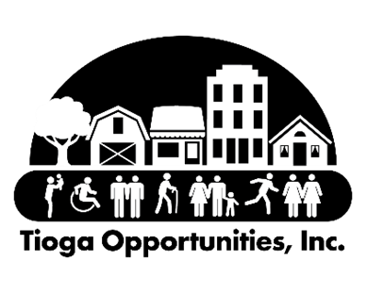

Tioga Opportunities, Inc.
9 Sheldon Guile Blvd.
Owego, New York 13827
www.tiogaopp.org

New York State Community Action Association, https://www.nyscommunityaction.org/assets/docs/2019-CAA-ED-Manual-Final.pdf
National Association for State Community Services Programs, https://nascsp.org/csbg/csbg-resources/roma/#:~:text=Results%20Oriented%20Accountability%20Principles&text=Use%20information%20about%20outcomes%2C%20or,funding%20and%20community%20partnership%20activities.
Community Action Partnership, Community Needs Assessment Resource Guide, September 15, 2018. https://communityactionpartnership.com/publication_toolkit/community-needs-assessment-resource-guide/
Breaking the Cycle: From Poverty to Financial Security for All, PolicyLink, https://www.policylink.org/sites/default/files/BreakingTheCycle_0.pdf
https://coronavirus.health.ny.gov/vaccination-progress-date
https://en.wikipedia.org/wiki/Tioga_County,_New_York#/media/File:Map_of_New_York_highlighting_Tioga_County.svg
https://www.ilovethefingerlakes.com/basics/maps-tiogacounty.htm
Tioga County Farmland Protection Update, 2015, https://www.tiogacountyny.com/media/5557/tioga-county-ag-farmland- protection-plan.pdf
Ibid
Tioga County Farmland Protection Update, 2015
Tioga County GIS
Tioga County Farmland Protection Update, 2015
Ibid
2018 American Community Survey, 5-year Estimates
U.S. Census Bureau, Quick Facts, Tioga County, NY July 2019 https://www.census.gov/quickfacts/tiogacountynewyork
2020 American Community Survey, 5-year Estimates
Ibid
Ibid
Tioga County Housing Study, 2017, https://www.tiogacountyny.com/media/5819/tioga-county-housing-study- 122817.pdf
County Projections Explorer by Cornell Program on Applied Demographic
Tioga County Housing Study, 2017, https://www.tiogacountyny.com/media/5819/tioga-county-housing-study- 122817.pdf
Cornell University Program on Applied Demographics, Tioga County Profile, 2017, https://pad.human.cornell.edu/profiles/Tioga.pdf
2020 American Community Survey
Ibid
Ibid
2020 American Community Survey – 5 Year Estimates
Unites States Department of Veteran Affairs, National Center for Veteran Analysis and Statistics, https://www.va.gov/vetdata/veteran_population.asp
Ibid
Ibid
2020 American Community Survey
Ibid
Ibid
Ibid
Ibid
Ibid
Tioga County Public Health, Community Health Assessment, 2019-2024, https://www.tiogacountyny.com/media/7278/tioga-county-community-health-assessment -20192024.pdf
AARST.ORG (Radon Info) EPA.GOV (Radon Info) https://county-radon.info/NY/Tioga.html
American Community Survey 2020, https://www.tiogacountyny.com/media/v1kpmavv/tioga-county-acs-data-profiles-2016-2020.pdf
Ibid
Ibid
Ibid
American Community Survey 2020, https://www.tiogacountyny.com/media/v1kpmavv/tioga-county-acs-data-profiles-2016-2020.pdf
Ibid
2015 American Community Survey, 5-Year Estimates
Tioga County Housing Study, 2018, https://tiogacountyny.gov/media/5808/tioga-county-housing-study-010818.pdf
Associated General Contractors of America
Tioga County Housing Study
Tioga Opportunities, Inc. Section 8 Housing Choice Voucher Data, January 2023
US Census Bureau Quick Facts, Tioga County, 2016-2020
Local employer interviews conducted by TOI, 2022
Ibid
Ibid
Data USA, Tioga County Profile, 2020 https://datausa.io/profile/geo/tioga-county-ny
Data USA, Tioga County Profile, 2020 https://datausa.io/profile/geo/tioga-county-ny
The 2020-2025 Tioga County Workforce Development Strategy
2016-2020 American Community Survey, 5-Year Estimates
Data USA, Tioga County Profile, 2020 https://datausa.io/profile/geo/tioga-county-ny
The 2020-2025 Tioga County Workforce Development Strategy
NYS OSC New York’s Labor Force, assessing 10-year trends and pandemic setbacks
Ibid
Paycheck Protection Program database https://ppp.directory/new-york/tioga-county
Forbes Magazine 11/11/21 Don’t Blame The Millennials: The Demographics Causing Talent Shortages and the Great Resignation
NYS Department of Labor
The 2020-2025 Tioga County Workforce Development Strategy
Livingwage.mit.edu & Data USA Tioga county profile, 2020
Community Foundation of South-Central New York 2019 Assessment
2016-20 American Community Survey, 5-Year Estimates
Data USA, Tioga County & New York Profile 2020
United Way ALICE Report, New York County Pages, 2020
Ibid
Tioga County Department of Social Services, 2020 Annual Report, https://www.tiogacountyny.com/media/9458/annual-report-2020-final.pdf
Ibid
Ibid
Ibid
U.S. Census, U.S. Census Bureau Releases New Educational Attainment Data, March
2020 American Community Survey, 5-Year Estimates, subject table S1501
Ibid
New York State Education Department, Tioga County Profile, https://data.nysed.gov/profile.php?county=060
The American Dream and the Power of Wealth: Choosing Schools and Inheriting Inequality in the Land of Opportunity, (pp.4-51), Johnson, Heather B. 2006. New York: Routledge.
Ibid
National Association of Realtors, Home Buyers, and Sellers Generational Trends, 2021, https://www.nar.realtor/sites/ default/files/documents/2021-home-buyers-and-sellers-generational-trends-03-16-2021.pdf
99 School Quality Influences Where Parents Choose to Live- and How Much They're Willing to Pay for Their Home; Goldstein A. & Orestes, P. Hastings. 2019. Sociological Science.
Tioga County Housing Study, 2017, https://www.tiogacountyny.com/media/5819/tioga-county-housing-study-122817.pdf
GreatSchools, https://www.greatschools.org/gk/ratings/. Accessed 9-2022.
Tioga County Housing Study, 2017, https://www.tiogacountyny.com/media/5819/tioga-county-housing-study-122817.pdf
Ibid
United States Department of Education, Chronic Absenteeism in the Nation’s Schools
Civil Rights Data Collection School and District Search, 2017 https://ocrdata.ed.gov/ DistrictSchoolSearch#districtSearch
New York State Education Department, Tioga County Profile, 2018, https://data.nysed.gov/profile.php?county=060
Ibid
New York State Education Department, Multiple Pathways to Graduation Curriculum Instruction Handout, http://www.nysed.gov/common/nysed/files/programs/curriculum-instruction/multiplepathwayshandout.pdf
Tioga Tells: Quality of Life Assessment, 2018-2019, https://rhnscny.org/wp-content/uploads/2019/07/Final-Report_Quality-of-Life-Assessment_TiogaTells2018.2019.pdf
Rural Health Network of South-Central New York website, https://rhnscny.org/transportation/
University of Minnesota Rural Health Research Center, Policy Brief: Rural Transportation: Challenges and Opportunities. November 2017.
“Transportation gaps may persist for rural older adults despite infrastructure dollars,” Deon J. Hampton, NBC News, May 24, 2022, https://www.nbcnews.com/news/us-news/transportation-gaps-may-persist-rural-older-adults-infrastructure-doll-rcna30264
Data USA, https://datausa.io/profile/geo/tioga-county-ny#economy
Ibid
Ibid
Data USA, https://datausa.io/profile/geo/tioga-county-ny#economy
Rural Health Network of South-Central New York website, https://rhnscny.org/transportation/
American Community Survey 5-year estimates, 2016-2020, Tioga County, https://tiogacountyny.com/media/v1kpmavv/tioga-county-acs-data-profiles-2016-2020.pdf
Binghamton Metropolitan Transportation Study, http://www.bmtsonline.com/
National Aging and Disability Transportation Center, https://www.nadtc.org/about/transportation-aging-disability/unique-issues-related-to-older-adults-and-transportation/
Rural Health Network of South-Central New York website, https://rhnscny.org/transportation/
Economics of Transportation Research Needs for Rural Elderly and Transportation Disadvantaged Populations, 2017. Mjelde, J.W., Dudensing, J. Brooks, Battista, G., Carrillo, B., Counsil, A. Giri, Pyrialakou, V.D., and Ullerich, S. Texas A&M University –COALS, AgriLife Extension, and Texas Transportation Institute College Station, TX.
Rural Health Information Hub, https://www.ruralhealthinfo.org/toolkits/transportation/4/population-considerations/older-adults-people-with-disabilities
Data from Rural Health Network of South-Central New York accessed January 2023.
Ibid
Ibid
Economics of Transportation Research Needs for Rural Elderly and Transportation Disadvantaged Populations, 2017. Mjelde, J.W., Dudensing, J. Brooks, Battista, G., Carrillo, B., Counsil, A. Giri, Pyrialakou, V.D., and Ullerich, S. Texas A&M University –COALS, AgriLife Extension, and Texas Transportation Institute College Station, TX. https://static.tti.tamu.edu/tti.edu/documents/TTI-2017-1.pdf
National Aging and Disability Transportation Center, https://www.nadtc.org/about/transportation-aging-disability/unique-issues-related-to-older-adults-and-transportation/
Economics of Transportation Research Needs for Rural Elderly and Transportation Disadvantaged Populations, 2017.
Tioga Tells: Quality of Life Assessment, 2018-2019, https://rhnscny.org/wp-content/uploads/2019/07/Final-Report_Quality-of-Life-Assessment_TiogaTells2018.2019.pdf
National Aging and Disability Transportation Center, https://www.nadtc.org/about/transportation-aging-disability/unique-issues-related-to-older-adults-and-transportation/
Binghamton Metropolitan Transportation Study, http://www.bmtsonline.com/
New York State Community Health Indicator Reports, https://webbi1.health.ny.gov/SASStoredProcess/guest?_program=/EBI/PHIG/apps/chir_dashboard/chir_dashboard&p=np&ind_id=Ng105#pagetitle
Health Resources and Services Administration, https://data.hrsa.gov
County Health Rankings, 2002, https://www.countyhealthrankings.org/app/new-york/2022/rankings/tioga/county/outcomes/overall/snapshot
New York State Community Health Indicator Reports https://webbi1.health.ny.gov/SASStoredProcess/guest?_program=%2FEBI%2FPHIG%2Fapps%2Fchir_dashboard%2Fchir_dashboard&p=ch&cos=49&ctop=14
Tioga County Public Health, Community Health Assessment, 2019-2024, https://www.tiogacountyny.com/media/7278/tioga-county-community-health-assessment-20192024.pdf
Tioga County Resource Guide https://tiogacountyny.com/media/7305/tiogacountyresourceguide.pdf
Tioga County Public Health, Community Health Assessment, 2019-2024, https://www.tiogacountyny.com/media/7278/tioga-county-community-health-assessment-20192024.pdf
Ibid
HealthCare.gov glossary, https://www.healthcare.gov/glossary/preventive-services/
U.S. Department of Health and Human Services, Preventive Care, https://www.hhs.gov/healthcare/about-the-aca/preventive-care/index.html
Data USA, https://datausa.io/profile/geo/tioga-county-ny#health
New York State Community Health Indicator Reports, https://webbi1.health.ny.gov/SASStoredProcess/guest?_program=%2FEBI%2FPHIG%2Fapps%2Fchir_dashboard%2Fchir_dashboard&p=ch&cos=49&ctop=14
Ibid
County Health Rankings, 2022 https://www.countyhealthrankings.org/app/new-york/2022/rankings/tioga/county/outcomes/overall/snapshot
Ibid
New York State Community Health Indicator Reports, https://webbi1.health.ny.gov/SASStoredProcess/guest?_program=%2FEBI%2FPHIG%2Fapps%2Fchir_dashboard%2Fchir_dashboard&p=ch&cos=49&ctop=14
Ibid
Ibid
2022 Tioga County Public Health Annual Report, https://www.tiogacountyny.com/media/aaxkqtnl/tioga-county-public-health-2021-annual-report.pdf
New York State Community Health Indicator Reports, https://webbi1.health.ny.gov/SASStoredProcess/guest?_program=%2FEBI%2FPHIG%2Fapps%2Fchir_dashboard%2Fchir_dashboard&p=ch&cos=49&ctop=14
Ibid
Ibid
Ibid
Ibid
Data USA, https://datausa.io/profile/geo/tioga-county-ny#health
New York State Community Health Indicator Reports, https://webbi1.health.ny.gov/SASStoredProcess/guest?_program=%2FEBI%2FPHIG%2Fapps%2Fchir_dashboard%2Fchir_dashboard&p=ch&cos=49&ctop=14
Ibid
Data USA, https://datausa.io/profile/geo/tioga-county-ny#health
New York State Community Health Indicators Report, https://webbi1.health.ny.gov/SASStoredProcess/guest?_program=%2FEBI%2FPHIG%2Fapps%2Fchir_dashboard%2Fchir_dashboard&p=ch&cos=49&ctop=1&ctop=3&ctop=4&ctop=10&ctop=11&ctop=12&ctop=14&ctop=15
Ibid
Ibid
Ibid
Ibid
Tioga County Public Health, Community Health Assessment, 2019-2024, https://www.tiogacountyny.com/media/7278/tioga-county-community-health-assessment-20192024.pdf
County Health Rankings, 2022, https://www.countyhealthrankings.org/app/new-york/2022/rankings/tioga/county/outcomes/overall/snapshot
County Health Rankings, 2022, https://www.countyhealthrankings.org/app/new-york/2022/rankings/tioga/county/outcomes/overall/snapshot
New York State Community Health Indicators Report, https://webbi1.health.ny.gov/SASStoredProcess/guest?_program=%2FEBI%2FPHIG%2Fapps%2Fchir_dashboard%2Fchir_dashboard&p=ch&cos=49&ctop=1&ctop=3&ctop=4&ctop=10&ctop=11&ctop=12&ctop=14&ctop=15
Ibid
Ibid
Ibid
Ibid
USDA Economic Research Service, https://www.ers.usda.gov/topics/food-choices-health/food-access/
Rural Health Information Hub, Rural Data Explorer, https://www.ruralhealthinfo.org/data-explorer?id=214&state=NY
New York State Community Health Indicators Report, https://webbi1.health.ny.gov/SASStoredProcess/guest?_program=%2FEBI%2FPHIG%2Fapps%2Fchir_dashboard%2Fchir_dashboard&p=ch&cos=49&ctop=1&ctop=3&ctop=4&ctop=10&ctop=11&ctop=12&ctop=14&ctop=15
Feeding America, Map the Meal Gap, https://map.feedingamerica.org/county/2020/overall/new-york/county/tioga
Ibid
County Health Rankings, 2022, https://www.countyhealthrankings.org/app/new-york/2022/measure/factors/133/map
Ibid
Tioga County Public Health, Community Health Assessment, 2019-2024, https://www.tiogacountyny.com/media/7278/tioga-county-community-health-assessment-20192024.pdf
New York State Community Health Indicators Report, https://webbi1.health.ny.gov/SASStoredProcess/guest?_program=%2FEBI%2FPHIG%2Fapps%2Fchir_dashboard%2Fchir_dashboard&p=ch&cos=49&ctop=1&ctop=3&ctop=4&ctop=10&ctop=11&ctop=12&ctop=14&ctop=15
Tioga Tells Quality of Life Assessment, 2018-2019, https://rhnscny.org/wp-content/uploads/2019/07/Final-Report_Quality-of-Life-Assessment_TiogaTells2018.2019.pdf
https://www.ers.usda.gov/topics/food-choices-health/food-access/
New York State Community Health Indicators Report, https://webbi1.health.ny.gov/SASStoredProcess/guest?_program=%2FEBI%2FPHIG%2Fapps%2Fchir_dashboard%2Fchir_dashboard&p=ch&cos=49&ctop=1&ctop=3&ctop=4&ctop=10&ctop=11&ctop=12&ctop=14&ctop=15
Ibid
Tioga County Public Health, Community Health Assessment, 2019-2024, https://www.tiogacountyny.com/media/7278/tioga-county-community-health-assessment-20192024.pdf
New York State Community Health Indicators Report, https://webbi1.health.ny.gov/SASStoredProcess/guest?_program=%2FEBI%2FPHIG%2Fapps%2Fchir_dashboard%2Fchir_dashboard&p=ch&cos=49&ctop=1&ctop=3&ctop=4&ctop=10&ctop=11&ctop=12&ctop=14&ctop=15
New York State Department of Health, Perinatal Data Profile, https://www.health.ny.gov/statistics/chac/perinatal/county/2017-2019/tioga.htm
New York State Community Health Indicators Report, https://webbi1.health.ny.gov/SASStoredProcess/guest?_program=%2FEBI%2FPHIG%2Fapps%2Fchir_dashboard%2Fchir_dashboard&p=ch&cos=49&ctop=1&ctop=3&ctop=4&ctop=10&ctop=11&ctop=12&ctop=14&ctop=15
Ibid
Centers for Disease Control and Prevention, National Center for Health Statistics, https://www.cdc.gov/nchs/fastats/deaths.htm
United Health Foundation, America’s Health Rankings, 2017, https://www.americashealthrankings.org/explore/annual/measure/YPLL/state/ALL
Tioga County Public Health, Community Health Assessment, 2019-2024, https://www.tiogacountyny.com/media/7278/tioga-county-community-health-assessment-20192024.pdf
Ibid
New York State Community Health Indicators Report, https://webbi1.health.ny.gov/SASStoredProcess/guest?_program=%2FEBI%2FPHIG%2Fapps%2Fchir_dashboard%2Fchir_dashboard&p=ch&cos=49&ctop=1&ctop=3&ctop=4&ctop=10&ctop=11&ctop=12&ctop=14&ctop=15
Tioga County Public Health 2021 Annual Report, https://www.tiogacountyny.com/media/aaxkqtnl/tioga-county-public-health-2021-annual-report.pdf
Ibid
Ibid
Ibid
Ibid
USA Facts, https://usafacts.org/visualizations/coronavirus-covid-19-spread-map/state/new-york/county/tioga-county
https://www.nytimes.com/interactive/2021/us/tioga-new-york-covid-cases.html
NYDatabases.com, https://data.democratandchronicle.com/covid-19-vaccine-tracker/new-york/tioga-county/36107/
https://thechildrensagenda.org/publications/rebuilding-our-future-child-care-closures-in-new-york-during-the-pandemic/
Ibid
New York State Division of Child Care Services, Day Care Facility Search. Accessed October 2022.
NYS Office of Children & Family Services
Family Enrichment Network Community Assessment 2022-2023
The Children’s Agenda/www.thechildrensagenda.org
NYS Office of Temporary and Disability Assistance Annual Report to the NYS Legislature
NYS Office of Temporary and Disability Assistance Annual Report to the NYS Legislature
https://ocfs.ny.gov/main/contracts/funding/COVID-relief/childcare-stabilization/
https://ocfs.ny.gov/main/contracts/funding/COVID-relief/childcare-stabilization/
Ibid
https://ocfs.ny.gov/main/reports/2022-Child-Care-Market-Rate-Survey.pdf
The Center for American Pogress: https://www.americanprogress.org/article/americas-child-care-deserts-2018/
https://ocfs.ny.gov/main/reports/2022-Child-Care-Market-Rate-Survey.pdf
https://ocfs.ny.gov/reports/childcare/Child-Care-Availability-Task-Force-Report.pdf
Tioga County Tourism, Experience Tioga, website. Accessed November 2022. https://experiencetioga.com/
Ibid
Office of International Trade Administration, Statistics and Research Programs, https://www.trade.gov/travel-and-tourism-research
New York State's Travel and Tourism Sector: A Statewide and Regional Analysis https://dol.ny.gov/system/files/ documents/2021/03/new-york-state-travel-and-tourism-sector.pdf
Tioga County 2021 Annual Report https://www.tiogacountyny.com/media/sj5lvdzp/team-tioga-2021-annual-report.pdf
Ibid
New York State Division of Criminal Justice Systems, Computerized Criminal History System, https://www.criminaljustice.ny.gov/crimnet/ojsa/stats.htm
Ibid
213 New York State Division of Criminal Justice Systems, Computerized Criminal History System, https://www.criminaljustice.ny.gov/crimnet/ojsa/stats.htm
Ibid
Ibid
Ibid
Tioga Tells: Quality of Life Assessment, 2018-2019, https://rhnscny.org/wp-content/uploads/2019/07/Final-Report_Quality- of-Life-Assessment_TiogaTells2018.2019.pdf
A New Hope Center, https://www.anewhopecenter.org/additional-services
New York State Division of Criminal Justice Systems, Computerized Criminal History System, https://www.criminaljustice.ny.gov/crimnet/ojsa/stats.htm
Tioga County Dept. of Social Services, 2021 Report
Ibid
Tioga County Emergency Services, https://www.tiogacountyny.com/departments/emergency-services/
Tioga County EMS Current State and Options for the Future, https://www.tiogacountyny.com/media/qace11tu/tiogactyemsrpt-final.pdf
Tioga County Sheriff Department, http://www.tiogacountysheriff.com/e911
Ibid
Ibid
Tioga County Comprehensive Emergency Management Plan, 2013, https://www.tiogacountyny.com/media/1574/tiogacempmarch112013rev452013.pdf
Tioga County Comprehensive Emergency Management Plan, 2013, https://www.tiogacountyny.com/media/1574/tiogacempmarch112013rev452013.pdf
Tioga County Comprehensive Emergency Management Plan, 2013, https://www.tiogacountyny.com/media/1574/tiogacempmarch112013rev452013.pdf
Ibid
Ibid

